ELEC 374 CPU Design – Phase 2

David-Alexandre Edwards (20099471),

Elan Bibas (20099396),

Hannah Berthiaume (20114482)

# Verilog Code

## DataPath

//added write signal to DataPath

module DataPath(

    input PCout, Zlowout, MDRout, MARin, Zin, PCin, MDRin, IRin, Yin, Read, Write,

     input [4:0] aluControl,

     input clock, clear,

    input Gra, Grb, Grc, Rin, Rout, BAout, Cout, ConIn, HIout, incPC

);

//registers run behavior every positive clock edge, bus will update BusMuxOUt when a change in register output is detected

//define signals that will connect regiters to bus

wire [31:0] BusMuxOut;

wire [31:0] BusMuxInR0;

wire [31:0] BusMuxInR1;

wire [31:0] BusMuxInR2;

wire [31:0] BusMuxInR3;

wire [31:0] BusMuxInR4;

wire [31:0] BusMuxInR5;

wire [31:0] BusMuxInR6;

wire [31:0] BusMuxInR7;

wire [31:0] BusMuxInR8;

wire [31:0] BusMuxInR9;

wire [31:0] BusMuxInR10;

wire [31:0] BusMuxInR11;

wire [31:0] BusMuxInR12;

wire [31:0] BusMuxInR13;

wire [31:0] BusMuxInR14;

wire [31:0] BusMuxInR15;

wire [31:0] BusMuxInZHi;

wire [31:0] BusMuxInZLo;

wire [31:0] BusMuxInPC;

wire [31:0] BusMuxInMDR;

wire [31:0] BusMuxInRinP;

wire [31:0] BusMuxInCSign;

wire [31:0] BusMuxInRY;

wire [31:0] ALULoOut;

wire [31:0] ALUHiOut;

//phase 2

wire [8:0] Address;

wire [31:0] ramOut;

wire [31:0] BusMuxInIR;

wire r0out;

wire r1out;

wire R2out;

wire r3out;

wire R4out;

wire r5out;

wire r6out;

wire r7out;

wire r8out;

wire r9out;

wire r10out;

wire r11out;

wire r12out;

wire r13out;

wire r14out;

wire r15out;

wire [31:0] BusMuxInRoutP;

wire [31:0] BusMuxInRHi;

// phase 3

wire branch;

//instantiate all register

 register R1(clock, clear, R1in, BusMuxOut, BusMuxInR1);

 register R2(clock, clear, R2in, BusMuxOut, BusMuxInR2);

 register R3(clock, clear, R3in, BusMuxOut, BusMuxInR3);

 register R4(clock, clear, R4in, BusMuxOut, BusMuxInR4);

 register R5(clock, clear, R5in, BusMuxOut, BusMuxInR5);

 register R6(clock, clear, R6in, BusMuxOut, BusMuxInR6);

 register R7(clock, clear, R7in, BusMuxOut, BusMuxInR7);

 register R8(clock, clear, R8in, BusMuxOut, BusMuxInR8);

 register R9(clock, clear, R9in, BusMuxOut, BusMuxInR9);

 register R10(clock, clear, R10in, BusMuxOut, BusMuxInR10);

 register R11(clock, clear, R11in, BusMuxOut, BusMuxInR11);

 register R12(clock, clear, R12in, BusMuxOut, BusMuxInR12);

 register R13(clock, clear, R13in, BusMuxOut, BusMuxInR13);

 register R14(clock, clear, R14in, BusMuxOut, BusMuxInR14);

 register R15(clock, clear, R15in, BusMuxOut, BusMuxInR15);

 register RHi(clock, clear, RHiIn, BusMuxOut, BusMuxInRHi);

 register RLO(clock, clear, RLOIn, BusMuxOut, BusMuxInRLo);

 register RZHi(clock, clear, Zin, ALUHiOut, BusMuxInZHi);

 register RZLO(clock, clear, Zin, ALULoOut, BusMuxInZLo);

 //register PC(clock, clear, PCIn, BusMuxOut, BusMuxInPC);

 register RInP(clock, clear, RInPIn, BusMuxOut, BusMuxInRInP);

 //register RCSign(clock, clear, RCSignIn, BusMuxOut, BusMuxInCSign);

 register RoutP(clock, clear, RoutPIn, BusMuxOut, BusMuxInRoutP);

 register RY(clock, clear, Yin, BusMuxOut, BusMuxInRY);

//phase 2 Select and Encode

 SelectEncode selectencode(BusMuxInIR, Gra, Grb, Grc, Rin, Rout, BAout, BusMuxInCSign, R0in, R1in, R2in, R3in, R4in, R5in, R6in, R7in, R8in, R9in, R10in, R11in, R12in, R13in, R14in, R15in, R0out, R1out, R2out, R3out, R4out, R5out, R6out, R7out, R8out, R9out, R10out, R11out, R12out, R13out, R14out, R15out);

 //phase 2 Memory subsystem

 register IR(clock, clear, IRin, BusMuxOut, BusMuxInIR);

 registerR0 R0(clock, clear, R0in, BAout, BusMuxOut, BusMuxInR0);

 MAR mar(clock, clear, MARin, BusMuxOut,Address);

 ram1 ram(Address,clock,BusMuxInMDR, Write, ramOut);

 MDR mdr(clock, clear, MDRin, Read, BusMuxOut, ramOut, BusMuxInMDR);

 pc PC(clock, clear, PCin, incPC, branch, BusMuxOut, BusMuxInPC); //incPC to PCin to '1

 //phase 2 conff

conff CONFF(BusMuxOut, BusMuxInIR, ConIn, branch);

//instantiate bus

bus cpuBUS(

    BusMuxInR0,BusMuxInR1,BusMuxInR2, BusMuxInR3,BusMuxInR4,BusMuxInR5,BusMuxInR6,BusMuxInR7,BusMuxInR8,BusMuxInR9,BusMuxInR10,BusMuxInR11,BusMuxInR12,BusMuxInR13,BusMuxInR14,BusMuxInR15,

    BusMuxInRHi,BusMuxInLo,BusMuxInZHi,BusMuxInZLo,BusMuxInPC,BusMuxInMDR,BusMuxInRInP,BusMuxInCSign,

    R0out,R1out,R2out,R3out,R4out,R5out,R6out,R7out,R8out,R9out,R10out,R11out,R12out,R13out,R14out,R15out,

    HIout,LOout,Zhighout,Zlowout,PCout,MDRout,INportout,Cout,BusMuxOut

);

ALU alu(aluControl, BusMuxInRY, BusMuxOut, ALULoOut, ALUHiOut);

endmodule

//we essentially need to perform an action anytime one of the control signals changes

// testbench changes state every rising-edge of clock, does the job associated with state for each

//#10 = time delay of 10 before instruction is ran, same concept with #15

// wires are used to create connection between to ports (input and output port), they do not store data, only drive data

// MDRout = 1, updates BusMuxOut with value of BusMuxInMDR, since R2in  =1, R2 will hold value (write to register)

// the always @ block is used for cyclic behavior

## Select & Encode

module SelectEncode(

input [31:0] IR,

input Gra, Grb, Grc, Rin, Rout, BAout,

output [31:0] C_sign,

output R0in, R1in, R2in, R3in, R4in, R5in, R6in, R7in, R8in, R9in, R10in, R11in, R12in, R13in, R14in, R15in,

output R0out, R1out, R2out, R3out, R4out, R5out, R6out, R7out, R8out, R9out, R10out, R11out, R12out, R13out, R14out, R15out

);

//have two outputs instead

reg [3:0] OpCode, Ra, Rb, Rc;

reg [3:0] DecoderInput;

reg [15:0] DecoderOutput;

reg [15:0] Out;

reg [31:0] C_sign_extended;

reg [15:0] In;

reg temp;

integer i;

always @ (*) begin

// Gra or Grb or Grc

OpCode = IR[31:27];

Ra = IR[26:23];

Rb = IR[22:19];

Rc = IR[18:15];

if(Gra == 1) begin //Add

DecoderInput = Ra;

end

else if(Grb == 1) begin //Sub

DecoderInput = Rb;

end

else if(Grc == 1) begin //Shift Right

DecoderInput = Rc;

end

if(DecoderInput == 4'b0000) begin

DecoderOutput = 16'b0000000000000001;

end

else if(DecoderInput == 4'b0001) begin

DecoderOutput = 16'b0000000000000010;

end

else if(DecoderInput == 4'b0010) begin

DecoderOutput = 16'b0000000000000100;

end

else if(DecoderInput == 4'b0011) begin

DecoderOutput = 16'b0000000000001000;

end

else if(DecoderInput == 4'b0100) begin

DecoderOutput = 16'b0000000000010000;

end

else if(DecoderInput == 4'b0101) begin

DecoderOutput = 16'b0000000000100000;

end

else if(DecoderInput == 4'b0110) begin

DecoderOutput = 16'b0000000001000000;

end

else if(DecoderInput == 4'b0111) begin

DecoderOutput = 16'b0000000010000000;

end

else if(DecoderInput == 4'b1000) begin

DecoderOutput = 16'b0000000100000000;

end

else if(DecoderInput == 4'b1001) begin

DecoderOutput = 16'b0000001000000000;

end

else if(DecoderInput == 4'b1010) begin

DecoderOutput = 16'b0000010000000000;

end

else if(DecoderInput == 4'b1011) begin

DecoderOutput = 16'b0000100000000000;

end

else if(DecoderInput == 4'b1100) begin

DecoderOutput = 16'b0001000000000000;

end

else if(DecoderInput == 4'b1101) begin

DecoderOutput = 16'b0010000000000000;

end

else if(DecoderInput == 4'b1110) begin

DecoderOutput = 16'b0100000000000000;

end

else if(DecoderInput == 4'b1111) begin

DecoderOutput = 16'b1000000000000000;

end

else begin

DecoderOutput = 16'b0000000000000000;

end

for (i = 0 ; i < 16 ; i = i + 1)

In[i] = DecoderOutput[i] & Rin;

temp = Rout | BAout;

for (i = 0 ; i < 16 ; i = i + 1)

Out[i] = DecoderOutput[i] & temp;

C_sign_extended = {{13{IR[18]}}, {IR[18:0]}};

end

assign {R15in, R14in, R13in, R12in, R11in, R10in, R9in, R8in, R7in, R6in, R5in, R4in, R3in, R2in, R1in, R0in} = In;

assign {R15out, R14out, R13out, R12out, R11out, R10out, R9out, R8out, R7out, R6out, R5out, R4out, R3out, R2out, R1out, R0out} = Out;

assign C_sign = C_sign_extended;

endmodule

## Conff

module conff(

    input [31:0] BusMuxIn,

    input [31:0] IR,  // C2 = IR[22:19]

    input ConIn, // phase 3

    output branch

);

/*

make input BusMuxInIR 32 bits and isolate the 4 required bits

output name should be controlOut

you should have an always block that runs anytime inputs change

assign statement will need to be outside of always block (may need a temp reg variable and assign output to that outside always block)

*/

reg temp;

reg temp2;

reg [3:0] BusMuxInIR;

integer i;

always @ (ConIn) begin

    BusMuxInIR = IR[22:19];

    if (BusMuxInIR[0] == 1'b1) begin

         temp = BusMuxInIR[0] & ~(|BusMuxIn);     // IR[0] AND Bus

         // decoder[0] & (|bus)

         if (temp == 1'b1) begin             // if equals 0

              temp2 = 1'b1;

         end

    end

    else if (BusMuxInIR[1] == 1'b1) begin

         temp = BusMuxInIR[1] & (|BusMuxIn);            // IR[1] AND (NOT Bus)

         if (temp != 1'b0) begin                 // if not equals 0

                                                                // not working, check with TA

              temp2 = temp;

         end

    end

    else if (BusMuxInIR[2] == 1'b1) begin

         temp = BusMuxInIR[2] & ~BusMuxIn[31];          // IR[2] AND (NOT Bus[31])

                                                                        // if greater than equal to 0

         temp2 = temp;

    end

    else if (BusMuxInIR[3] == 1'b1) begin

         temp = BusMuxInIR[3] & BusMuxIn[31];           // IR[3] AND Bus[31]

                                                                    // if less than 0

         temp2 = temp;

    end

    if (ConIn == 1'b0) begin

        temp2 = 1'b0;

    end

end

assign branch = temp2; // (((temp[0] | temp[1]) | temp[2]) | temp[3]);

endmodule

## MAR

module MAR(input clock, input clear, input MARin, input [31:0] BusMuxOut, output [8:0] Address);

reg [31:0] q;

    // Behavioral section for writing to the register

    always @ ( posedge clock)

        begin

            if(clear) begin

                q <= 32'b0;

            end

            else if(MARin) begin

                q <= BusMuxOut;

            end

        end

    assign Address = q[8:0];

endmodule

## MDR

module MDR(

    input clk, clear, MDRin, read,

    input [31:0] BusMuxOut,

    input [31:0] Mdatain,

    output [31:0] BusMuxInMDR

);

// Behavioral section for writing to the register

reg [31:0] Din;

reg [31:0] In;

always @ (posedge clk)

    begin

        if (read) begin

            Din <= Mdatain;

        end

        else begin

            Din<= BusMuxOut;

        end

        if(clear) begin

            In <= 32'b0;

        end

        else if(MDRin) begin

            In <= Din;

        end

    end

    assign BusMuxInMDR = In;

endmodule

## RAM

// megafunction wizard: %RAM: 1-PORT%

// GENERATION: STANDARD

// VERSION: WM1.0

// MODULE: altsyncram

// ============================================================

// File Name: ram1.v

// Megafunction Name(s):

//          altsyncram

//

// Simulation Library Files(s):

//          altera_mf

// ============================================================

// ************************************************************

// THIS IS A WIZARD-GENERATED FILE. DO NOT EDIT THIS FILE!

//

// 13.0.1 Build 232 06/12/2013 SP 1 SJ Full Version

// ************************************************************

//Copyright (C) 1991-2013 Altera Corporation

//Your use of Altera Corporation's design tools, logic functions

//and other software and tools, and its AMPP partner logic

//functions, and any output files from any of the foregoing

//(including device programming or simulation files), and any

//associated documentation or information are expressly subject

//to the terms and conditions of the Altera Program License

//Subscription Agreement, Altera MegaCore Function License

//Agreement, or other applicable license agreement, including,

//without limitation, that your use is for the sole purpose of

//programming logic devices manufactured by Altera and sold by

//Altera or its authorized distributors.  Please refer to the

//applicable agreement for further details.

// synopsys translate_off

`timescale 1 ps / 1 ps

// synopsys translate_on

module ram1 (

    address,

    clock,

    data,

    wren,

    q);

    input   [8:0]  address;

    input     clock;

    input   [31:0]  data;

    input     wren;

    output  [31:0]  q;

`ifndef ALTERA_RESERVED_QIS

// synopsys translate_off

`endif

    tri1      clock;

`ifndef ALTERA_RESERVED_QIS

// synopsys translate_on

`endif

    wire [31:0] sub_wire0;

    wire [31:0] q = sub_wire0[31:0];

    altsyncram  altsyncram_component (

                .address_a (address),

                .clock0 (clock),

                .data_a (data),

                .wren_a (wren),

                .q_a (sub_wire0),

                .aclr0 (1'b0),

                .aclr1 (1'b0),

                .address_b (1'b1),

                .addressstall_a (1'b0),

                .addressstall_b (1'b0),

                .byteena_a (1'b1),

                .byteena_b (1'b1),

                .clock1 (1'b1),

                .clocken0 (1'b1),

                .clocken1 (1'b1),

                .clocken2 (1'b1),

                .clocken3 (1'b1),

                .data_b (1'b1),

                .eccstatus (),

                .q_b (),

                .rden_a (1'b1),

                .rden_b (1'b1),

                .wren_b (1'b0));

    defparam

        altsyncram_component.clock_enable_input_a = "BYPASS",

        altsyncram_component.clock_enable_output_a = "BYPASS",

`ifdef NO_PLI

        altsyncram_component.init_file = "lab.rif"

`else

        altsyncram_component.init_file = "lab.hex"

`endif

,

        altsyncram_component.intended_device_family = "Cyclone III",

        altsyncram_component.lpm_hint = "ENABLE_RUNTIME_MOD=NO",

        altsyncram_component.lpm_type = "altsyncram",

        altsyncram_component.numwords_a = 512,

        altsyncram_component.operation_mode = "SINGLE_PORT",

        altsyncram_component.outdata_aclr_a = "NONE",

        altsyncram_component.outdata_reg_a = "UNREGISTERED",

        altsyncram_component.power_up_uninitialized = "FALSE",

        altsyncram_component.read_during_write_mode_port_a = "DONT_CARE",

        altsyncram_component.widthad_a = 9,

        altsyncram_component.width_a = 32,

        altsyncram_component.width_byteena_a = 1;

endmodule

// ============================================================

// CNX file retrieval info

// ============================================================

// Retrieval info: PRIVATE: ADDRESSSTALL_A NUMERIC "0"

// Retrieval info: PRIVATE: AclrAddr NUMERIC "0"

// Retrieval info: PRIVATE: AclrByte NUMERIC "0"

// Retrieval info: PRIVATE: AclrData NUMERIC "0"

// Retrieval info: PRIVATE: AclrOutput NUMERIC "0"

// Retrieval info: PRIVATE: BYTE_ENABLE NUMERIC "0"

// Retrieval info: PRIVATE: BYTE_SIZE NUMERIC "8"

// Retrieval info: PRIVATE: BlankMemory NUMERIC "0"

// Retrieval info: PRIVATE: CLOCK_ENABLE_INPUT_A NUMERIC "0"

// Retrieval info: PRIVATE: CLOCK_ENABLE_OUTPUT_A NUMERIC "0"

// Retrieval info: PRIVATE: Clken NUMERIC "0"

// Retrieval info: PRIVATE: DataBusSeparated NUMERIC "1"

// Retrieval info: PRIVATE: IMPLEMENT_IN_LES NUMERIC "0"

// Retrieval info: PRIVATE: INIT_FILE_LAYOUT STRING "PORT_A"

// Retrieval info: PRIVATE: INIT_TO_SIM_X NUMERIC "0"

// Retrieval info: PRIVATE: INTENDED_DEVICE_FAMILY STRING "Cyclone III"

// Retrieval info: PRIVATE: JTAG_ENABLED NUMERIC "0"

// Retrieval info: PRIVATE: JTAG_ID STRING "NONE"

// Retrieval info: PRIVATE: MAXIMUM_DEPTH NUMERIC "0"

// Retrieval info: PRIVATE: MIFfilename STRING "lab.hex"

// Retrieval info: PRIVATE: NUMWORDS_A NUMERIC "512"

// Retrieval info: PRIVATE: RAM_BLOCK_TYPE NUMERIC "0"

// Retrieval info: PRIVATE: READ_DURING_WRITE_MODE_PORT_A NUMERIC "2"

// Retrieval info: PRIVATE: RegAddr NUMERIC "1"

// Retrieval info: PRIVATE: RegData NUMERIC "1"

// Retrieval info: PRIVATE: RegOutput NUMERIC "0"

// Retrieval info: PRIVATE: SYNTH_WRAPPER_GEN_POSTFIX STRING "0"

// Retrieval info: PRIVATE: SingleClock NUMERIC "1"

// Retrieval info: PRIVATE: UseDQRAM NUMERIC "1"

// Retrieval info: PRIVATE: WRCONTROL_ACLR_A NUMERIC "0"

// Retrieval info: PRIVATE: WidthAddr NUMERIC "9"

// Retrieval info: PRIVATE: WidthData NUMERIC "32"

// Retrieval info: PRIVATE: rden NUMERIC "0"

// Retrieval info: LIBRARY: altera_mf altera_mf.altera_mf_components.all

// Retrieval info: CONSTANT: CLOCK_ENABLE_INPUT_A STRING "BYPASS"

// Retrieval info: CONSTANT: CLOCK_ENABLE_OUTPUT_A STRING "BYPASS"

// Retrieval info: CONSTANT: INIT_FILE STRING "lab.hex"

// Retrieval info: CONSTANT: INTENDED_DEVICE_FAMILY STRING "Cyclone III"

// Retrieval info: CONSTANT: LPM_HINT STRING "ENABLE_RUNTIME_MOD=NO"

// Retrieval info: CONSTANT: LPM_TYPE STRING "altsyncram"

// Retrieval info: CONSTANT: NUMWORDS_A NUMERIC "512"

// Retrieval info: CONSTANT: OPERATION_MODE STRING "SINGLE_PORT"

// Retrieval info: CONSTANT: OUTDATA_ACLR_A STRING "NONE"

// Retrieval info: CONSTANT: OUTDATA_REG_A STRING "UNREGISTERED"

// Retrieval info: CONSTANT: POWER_UP_UNINITIALIZED STRING "FALSE"

// Retrieval info: CONSTANT: READ_DURING_WRITE_MODE_PORT_A STRING "DONT_CARE"

// Retrieval info: CONSTANT: WIDTHAD_A NUMERIC "9"

// Retrieval info: CONSTANT: WIDTH_A NUMERIC "32"

// Retrieval info: CONSTANT: WIDTH_BYTEENA_A NUMERIC "1"

// Retrieval info: USED_PORT: address 0 0 9 0 INPUT NODEFVAL "address[8..0]"

// Retrieval info: USED_PORT: clock 0 0 0 0 INPUT VCC "clock"

// Retrieval info: USED_PORT: data 0 0 32 0 INPUT NODEFVAL "data[31..0]"

// Retrieval info: USED_PORT: q 0 0 32 0 OUTPUT NODEFVAL "q[31..0]"

// Retrieval info: USED_PORT: wren 0 0 0 0 INPUT NODEFVAL "wren"

// Retrieval info: CONNECT: @address_a 0 0 9 0 address 0 0 9 0

// Retrieval info: CONNECT: @clock0 0 0 0 0 clock 0 0 0 0

// Retrieval info: CONNECT: @data_a 0 0 32 0 data 0 0 32 0

// Retrieval info: CONNECT: @wren_a 0 0 0 0 wren 0 0 0 0

// Retrieval info: CONNECT: q 0 0 32 0 @q_a 0 0 32 0

// Retrieval info: GEN_FILE: TYPE_NORMAL ram1.v TRUE

// Retrieval info: GEN_FILE: TYPE_NORMAL ram1.inc FALSE

// Retrieval info: GEN_FILE: TYPE_NORMAL ram1.cmp FALSE

// Retrieval info: GEN_FILE: TYPE_NORMAL ram1.bsf FALSE

// Retrieval info: GEN_FILE: TYPE_NORMAL ram1_inst.v FALSE

// Retrieval info: GEN_FILE: TYPE_NORMAL ram1_bb.v TRUE

// Retrieval info: LIB_FILE: altera_mf

## PC

module pc #(parameter VAL = 0)(

    input clock,

    input clear,

    input enable,

    input incPC,

    input branch,

    input [31:0] BusMuxOut,

    output [31:0] BusMuxIn

);

reg [31:0] q;

initial q = VAL;

    // Behavioral section for writing to the register

    always @ (posedge clock)

        begin

            if(clear) begin

                q <= 32'b0;

            end

            else if(enable) begin

                q <= BusMuxOut;

            end

            else if(incPC) begin

                q <= q + 1;

            end

            else if(branch) begin

                q <= q + BusMuxOut;

            end

        end

    assign BusMuxIn = q;

endmodule

## Bus

module bus(input [31:0] BusMuxInR0, input [31:0] BusMuxInR1, input [31:0] BusMuxInR2, input [31:0] BusMuxInR3,input [31:0] BusMuxInR4,input [31:0] BusMuxInR5,input [31:0] BusMuxInR6,input [31:0] BusMuxInR7,input [31:0] BusMuxInR8,input [31:0] BusMuxInR9,input [31:0] BusMuxInR10,

input [31:0] BusMuxInR11,input [31:0] BusMuxInR12,input [31:0] BusMuxInR13,input [31:0] BusMuxInR14,input [31:0] BusMuxInR15,input [31:0] BusMuxInHi,input [31:0] BusMuxInLo,input [31:0] BusMuxInZHi,input [31:0] BusMuxInZLo,input [31:0] BusMuxInPC,

input [31:0] BusMuxInMDR,input [31:0] BusMuxInRInP,input [31:0] BusMuxInRCSign, input R0out, input R1out,input R2out,input R3out,input R4out,input R5out,input R6out,input R7out,input R8out,input R9out,input R10out,input R11out,input R12out,

input R13out,input R14out,input R15out,input HIout,input LOout,input Zhighout,input Zlowout,input PCout, input MDRout,input InPortout,input Cout, output [31:0] BusMuxOut);

reg [31:0] out;

always @ (*) begin

// R0out or R1out or R2out or R4out or R5out or R6out or R7out or R8out or R9out or R10out or R11out or R12out or R13out or R14out or R15out or MDRout or PCout or HIout or LOout or Zhighout or Zlowout or InPortout or Cout

    if(R0out) begin

        out = BusMuxInR0;

    end

    else if(Cout) begin

        out =  BusMuxInRCSign;

    end

    else if(R1out) begin

        out = BusMuxInR1;

    end

    else if(R2out) begin

        out = BusMuxInR2;

    end

    else if(R3out) begin

        out = BusMuxInR3;

    end

    else if(R4out) begin

        out = BusMuxInR4;

    end

    else if(R5out) begin

        out = BusMuxInR5;

    end

    else if(R6out) begin

        out = BusMuxInR6;

    end

    else if(R7out) begin

        out = BusMuxInR7;

    end

    else if(R8out) begin

        out = BusMuxInR8;

    end

    else if(R9out) begin

        out = BusMuxInR9;

    end

    else if(R10out) begin

        out = BusMuxInR10;

    end

    else if(R11out) begin

        out = BusMuxInR11;

    end

    else if(R12out) begin

        out = BusMuxInR12;

    end

    else if(R13out)begin

        out = BusMuxInR13;

    end

    else if(R14out)begin

        out = BusMuxInR14;

    end

    else if(R15out)begin

        out = BusMuxInR15;

    end

    else if(HIout)begin

        out = BusMuxInHi;

    end

    else if(LOout)begin

        out = BusMuxInLo;

    end

    else if(Zhighout)begin

        out = BusMuxInZHi;

    end

    else if(Zlowout)begin

        out = BusMuxInZLo;

    end

    else if(PCout)begin

        out = BusMuxInPC;

    end

    else if(MDRout)begin

        out = BusMuxInMDR;

    end

    else if(InPortout)begin

        out = BusMuxInRInP;

    end

//  else if(Cout) begin

//      out =  BusMuxInRCSign;

//  end

    else begin

        out = 32'bx;

    end

end

assign BusMuxOut = out;

endmodule

## ALU

module ALU(

    input [4:0] aluControl,

    input [31:0] BusMuxInY,

     input [31:0] BusMuxOut,

    output [31:0] Zlowout,

     output [31:0] Zhighout

);

//have two outputs instead

//reg [4:0] aluControl;

reg [31:0] COut;

reg [31:0] temp;

reg [31:0] temp1;

reg [31:0] temp2;

wire [63:0] ZOut;

integer i;

boothmult Mult(ZOut, BusMuxInY, BusMuxOut);

always @ (*) begin

     // aluControl = Operator[31:27];

     temp1 = BusMuxOut;

     temp2 = BusMuxInY;

    if(aluControl == 5'b00011) begin //Add

        COut = BusMuxInY + BusMuxOut;

     end

    else if(aluControl == 5'b00100) begin //Sub

        COut = BusMuxInY - BusMuxOut;

     end

    else if(aluControl == 5'b00101) begin //Shift Right

        for (i = 0 ; i < 31 ; i = i + 1) begin

            COut[i] = BusMuxInY[i+1];

          end

        COut[31] = 0;

     end

    else if(aluControl == 5'b00110) begin //Shift Left

          for (i = 1 ; i < 32 ; i = i + 1) begin

            COut[i] = BusMuxInY[i-1];

          end

        COut[0] = 0;

     end

    else if(aluControl == 5'b00111) begin //Rotate Right

        for (i = 0 ; i < 31 ; i = i + 1) begin

            COut[i] = BusMuxInY[i+1];

          end

        COut[31] = BusMuxInY[0];

     end

    else if(aluControl == 5'b01000) begin //Rotate Left

          for (i = 1 ; i < 32 ; i = i + 1) begin

            COut[i] = BusMuxInY[i-1];

          end

        COut[0] = BusMuxInY[31];

     end

    else if(aluControl == 5'b01001) begin //AND

    //loop with for loop, then use logial and for each bit

        for (i = 0 ; i < 32 ; i = i + 1) begin

            COut = (BusMuxInY & temp1);

        end

    end

    else if(aluControl == 5'b01010) begin //OR

        for (i = 0 ; i < 32 ; i = i + 1) begin

            COut[i] = BusMuxInY[i] | BusMuxOut[i];

        end

    end

    else if(aluControl == 5'b01110) begin //Multiply

        COut = ZOut[31:0];

        temp = ZOut[63:32];

     end

    else if(aluControl == 5'b01111) begin //Divide

        COut = BusMuxInY / BusMuxOut;

     end

    else if(aluControl == 5'b10000) begin // Negate

        for (i = 0 ; i < 32 ; i = i + 1) begin

                COut[i] = ~temp1[i];

          end

          COut[0] = COut[0] + 1'b1;

     end

    else if(aluControl == 5'b10001) begin // Not

        for (i = 0 ; i < 32 ; i = i + 1) begin

                COut[i] = ~temp1[i];

          end

     end

     if(aluControl != 5'b01111)

        temp = {32{COut[31]}};

    // assign the results to z high and z low

end

assign Zhighout = temp; // ZOut[31:0]

assign Zlowout = COut;  // ZOut[63:32]

endmodule

// Z register holds the results of the operation in ALU

# Testbenches and Simulation runs

Note that for all testbenches, steps T0-T2 are used to fetch the instruction from memory at address 0 by preloading the value of 0 in the PC (PCout = 1 and MARIn=1 to store address 0 in MAR for memory access of ram). Read and MDRIn are set to 1 in order to store the instruction, which is then transferred to the IR via the bus (MDRout=1 and IRin=1). The instruction bit pattern is displayed by the contents of IR in all signal printouts.

### Load Instruction – ld R1, $85

In this case, we are preloading the value of 0 into R0. The select and encode module sets R0out to 1 in order to retrieve the value and store it into the Y register to compute the addition with the sign extended value 85. The result is then sent to the MAR via the bus to perform a memory read at the address 0x55 computed (85 in decimal). To verify, we placed a value of 1 at that address and checked that R1 contained 1.

`timescale 1ns/10ps

module memtb;

reg PCout, Zlowout, MDRout; // add any other signals to see in your simulation

reg MARin, Zin, PCin, MDRin, IRin, Yin;

reg incPC, Read;

reg [4:0] Operator;

reg clk;

reg clear, Write;

reg Gra, Grb, Grc, Rin, Rout, BAout, Cout;

parameter Default = 4'b0000, T0= 4'b0111,T1= 4'b1000,T2= 4'b1001, T3= 4'b1010, T4= 4'b1011, T5= 4'b1100,T6= 4'b1101,T7= 4'b1110;

reg[3:0] Present_state= Default;

DataPath DUT(PCout, Zlowout, MDRout, MARin, Zin, PCin, MDRin, IRin, Yin, incPC, Read, Write, Operator, clk, clear,

Gra, Grb, Grc, Rin, Rout, BAout,Cout);

initial begin

clk = 0;

forever #10 clk = ~clk;

end

always @(posedge clk) //finite state machine; if clk rising-edge

begin

case (Present_state)

Default : #40 Present_state = T0;

T0 : #40 Present_state = T1;

T1 : #40 Present_state = T2;

T2 : #40 Present_state = T3;

T3 : #40 Present_state = T4;

T4 : #40 Present_state = T5;

T5 : #40 Present_state = T6;

T6 : #40 Present_state = T7;

endcase

end

always @(Present_state) // do the required job in each state

begin

case (Present_state) //assert the required signals in each clk cycle

Default: begin

PCout <= 0; Zlowout <= 0; MDRout<= 0; //initialize the signals

MARin <= 0; Zin <= 0;

PCin <=0; MDRin <= 0; IRin <= 0; Yin <= 0;

incPC <= 0; Read <= 0; Operator <= 5'b00000;

Gra<= 0; Grb<= 0; Grc<= 0; Rin<= 0; Rout<= 0; BAout<= 0; Cout<=0;

clear <= 1; //initialize registers to 0

#10 clear <= 0;

end

T0: begin

//load value in PC register (0) in MAR

#5 PCout <= 1;

#5 MARin <= 1; //incPC <= 1; Zin <= 1; used to inc PC by 4

end

T1: begin

//Zlowout <= 1; PCin <= 1;

PCout <= 0;

//MDR will grab value from ram @ address 0, this addess should contain instruction

#5 Read <= 1;

#5 MDRin <= 1;

end

T2: begin

Read <= 0;

MARin <= 0;

MDRin <= 0;

//load MDR value to bus which contains instruction, instruction is then stored in IR

MDRout<= 1; IRin <= 1;

end

T3: begin

MDRout<= 0;

IRin <= 0;

//select R0out since Rb = 0000

Grb <= 1;

//set to 1 to generate R0out = 1 and store value of R0 (0) into Y register

BAout <= 1;

Yin <= 1;

#5 Grb <= 0;

end

T4: begin

BAout <= 0;

Yin <= 0;

//store C sign extended value on bus (should be 85 decimal)

Cout <=1;

//perform add between 85/BuxMuxOut + R0 (0)/BuxMuxInY

Operator <= 5'b00011;

//store result in Z register

Zin <=1;

end

//read from ram

T5: begin

Cout <= 0;

Zin <=0;

// Grb <= 0;

//store Z register contents (85) in bus

Zlowout <= 1;

//load 85/busMuxOut into MAR to get address of 85

MARin <= 1;

end

T6: begin

Zlowout <=0;

MARin<=0;

//read from ram at address 85 and load that value in MDR -> we will need to have a preset value in memory at address 85

Read <= 1;

MDRin <= 1;

end

T7: begin

Read <= 0;

MDRin <= 0;

//load value in MDR on Bus

MDRout <= 1;

//set R1in signal to 1, value that was in memory at address 85 should now be stored in R1

Gra <= 1; //RA in Selectencode should be 0001 in binary

Rin <= 1;

end

endcase

end

endmodule

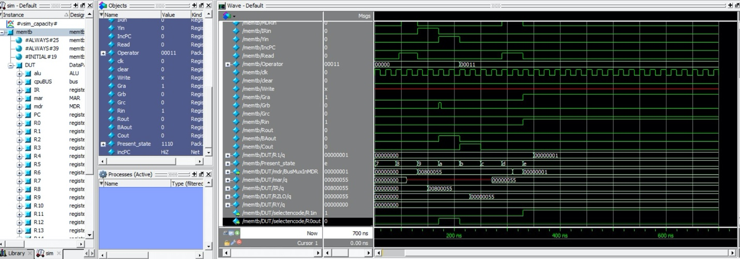

### Load Instruction – ld R0, $35(R1)

In this case, we are preloading the value of 5 into R1. The select and encode module sets R1out to 1 in order to retrieve the value and store it into the Y register to compute the addition with the sign extended value 35. The result is then sent to the MAR via the bus to perform a memory read at the address 0x28 computed (40 in decimal). To verify, we placed a value of 1 at that address and checked that R0 contained 1.

`timescale 1ns/10ps

module memtb;

reg PCout, Zlowout, MDRout, R2out, R4out;

reg MARin, Zin, PCin, MDRin, IRin, Yin;

reg incPC, Read;

reg [4:0] Operator;

reg clk;

reg clear,Write;

reg Gra, Grb, Grc, Rin, Rout, BAout, Cout;

parameter Default = 4'b0000, T0= 4'b0111, T1= 4'b1000, T2= 4'b1001, T3= 4'b1010, T4= 4'b1011, T5= 4'b1100,T6= 4'b1101,T7= 4'b1110;

reg[3:0] Present_state= Default;

DataPath DUT(PCout, Zlowout, MDRout, MARin, Zin, PCin, MDRin, IRin, Yin, Read, Write, Operator, clk, clear,

Gra, Grb, Grc, Rin, Rout, BAout,Cout);

initial begin

clk = 0;

forever #10 clk = ~clk;

end

always @(posedge clk) //finite state machine; if clk rising-edge

begin

case (Present_state)

Default : #40 Present_state = T0;

T0 : #40 Present_state = T1;

T1 : #40 Present_state = T2;

T2 : #40 Present_state = T3;

T3 : #40 Present_state = T4;

T4 : #40 Present_state = T5;

T5 : #40 Present_state = T6;

T6 : #40 Present_state = T7;

endcase

end

always @(Present_state) // do the required job ineach state

begin

case (Present_state) //assert the required signals in each clk cycle

Default: begin

PCout <= 0; Zlowout <= 0; MDRout<= 0; //initialize the signals

MARin <= 0; Zin <= 0;

PCin <=0; MDRin <= 0; IRin <= 0; Yin <= 0;

incPC <= 0; Read <= 0; Operator <= 5'b00000;

Gra<= 0; Grb<= 0; Grc<= 0; Rin<= 0; Rout<= 0; BAout<= 0; Cout<=0;

clear <= 1; //initialize registers to 0

#10 clear <= 0;

end

T0: begin

//load value in PC register (0) in MAR

#5 PCout <= 1;

#5 MARin <= 1;

end

T1: begin

PCout <= 0;

//MDR will grab value from ram @ address 0, this addess should contain instruction

#5 Read <= 1;

#5 MDRin <= 1;

end

T2: begin

Read <= 0;

MARin <= 0;

MDRin <= 0;

//load MDR value to bus which contains instruction, instruction is then stored in IR

MDRout<= 1; IRin <= 1;

end

T3: begin

MDRout<= 0;

IRin <= 0;

//select R1out since Rb = 0001

Grb <= 1;

//set to 1 to generate R1out = 1 and store value of R1 (5 decimal) into Y register

BAout <= 1;

Yin <= 1;

#5 Grb <= 0;

end

T4: begin

BAout <= 0;

Yin <= 0;

//store C sign extended value on bus (should be 35 decimal)

Cout <=1;

//perform add between 35/BuxMuxOut + R1 (5)/BuxMuxInY

Operator <= 5'b00011;

//store result in Z register

Zin <=1;

end

//read from ram

T5: begin

Cout <= 0;

Zin <=0;

//store Z register contents (40) in bus

Zlowout <= 1;

//load 40/busMuxOut into MAR to get address of 40

MARin <= 1;

end

T6: begin

Zlowout <=0;

MARin<=0;

//read from ram at address 40 and load that value in MDR -> we will need to have a preset value in memory at address 40

Read <= 1;

MDRin <= 1;

end

T7: begin

Read <= 0;

MDRin <= 0;

//load value in MDR on Bus

MDRout <= 1;

//set R0in signal to 1, value that was in memory at address 40 should now be stored in R1

Gra <= 1; //RA in Selectencode should be 0001 in binary

Rin <= 1;

end

endcase

end

endmodule

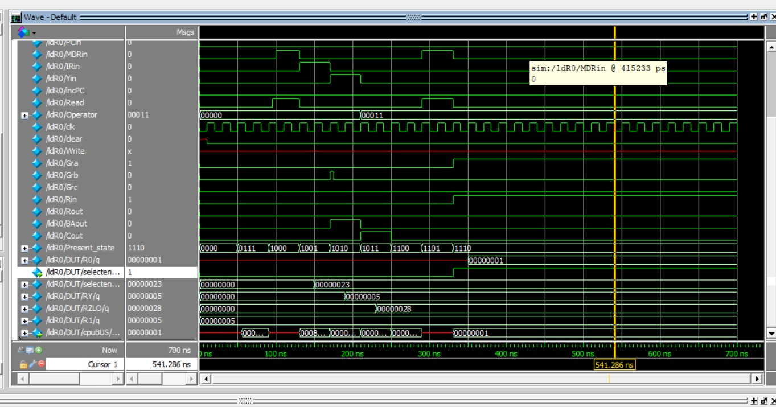

### Load Instruction – ldi R1, $85

The testbench written to test this instruction required less steps as the value in the instruction is directly loaded to register R1. That is, the C sign extended value contains 0x55 (85), Gra and Rin =1 to isolate the four bits in the instruction that correspond to 0001 to set R1in to 1 and load the immediate value 0x55 in R1. The results clearly indicate that R1 contains 0x55 (85) after the fifth cycle.

`timescale 1ns/10ps

module ldiR1;

reg PCout, Zlowout, MDRout, R2out, R4out;// add any other signals to see in your simulation

reg MARin, Zin, PCin, MDRin, IRin, Yin;

reg incPC, Read;

reg [4:0] Operator;

reg clk;

reg clear,Write;

reg Gra, Grb, Grc, Rin, Rout, BAout, Cout;

parameter Default = 4'b0000, T0= 4'b0111,T1= 4'b1000,T2= 4'b1001, T3= 4'b1010, T4= 4'b1011, T5= 4'b1100,T6= 4'b1101,T7= 4'b1110;

reg[3:0] Present_state= Default;

DataPath DUT(PCout, Zlowout, MDRout, MARin, Zin, PCin, MDRin, IRin, Yin, Read, Write, Operator, clk, clear,

Gra, Grb, Grc, Rin, Rout, BAout,Cout);

initial begin

clk = 0;

forever #10 clk = ~clk;

end

always @(posedge clk) //finite state machine; if clk rising-edge

begin

case (Present_state)

Default : #40 Present_state = T0;

T0 : #40 Present_state = T1;

T1 : #40 Present_state = T2;

T2 : #40 Present_state = T3;

T3 : #40 Present_state = T4;

T4 : #40 Present_state = T5;

endcase

end

always @(Present_state) // do the required job ineach state

begin

case (Present_state) //assert the required signals in each clk cycle

Default: begin

PCout <= 0; Zlowout <= 0; MDRout<= 0; //initialize the signals

MARin <= 0; Zin <= 0;

PCin <=0; MDRin <= 0; IRin <= 0; Yin <= 0;

incPC <= 0; Read <= 0; Operator <= 5'b00000;

Gra<= 0; Grb<= 0; Grc<= 0; Rin<= 0; Rout<= 0; BAout<= 0; Cout<=0;

clear <= 1; //initialize registers to 0

#10 clear <= 0;

end

T0: begin

//load value in PC register (0) in MAR

#5 PCout <= 1;

#5 MARin <= 1; //IncPC <= 1; Zin <= 1; used to inc PC by 4

end

T1: begin

//Zlowout <= 1; PCin <= 1;

PCout <= 0;

//MDR will grab value from ram @ address 0, this addess should contain instruction

#5 Read <= 1;

#5 MDRin <= 1;

end

T2: begin

Read <= 0;

MARin <= 0;

MDRin <= 0;

//load MDR value to bus which contains instruction, instruction is then stored in IR

MDRout<= 1; IRin <= 1;

end

T3: begin

MDRout<= 0;

IRin <= 0;

//select R0out since Rb = 0000

Grb <= 1;

//set to 1 to generate R0out = 1

BAout <= 1;

Yin <= 1;

#5 Grb <= 0;

end

T4: begin

BAout <= 0;

Yin <= 0;

//store C sign extended value on bus (should be 85 decimal)

Cout <=1;

//perform add between 85/BuxMuxOut + R0 (0)/BuxMuxInY

Operator <= 5'b00011;

//store result in Z register

Zin <=1;

end

//read from ram

T5: begin

Cout <= 0;

Zin <=0;

//store Z register contents (85) in bus

Zlowout <= 1;

Gra <= 1; //RA in Selectencode should be 0001 in binary

Rin <= 1;

end

endcase

end

endmodule

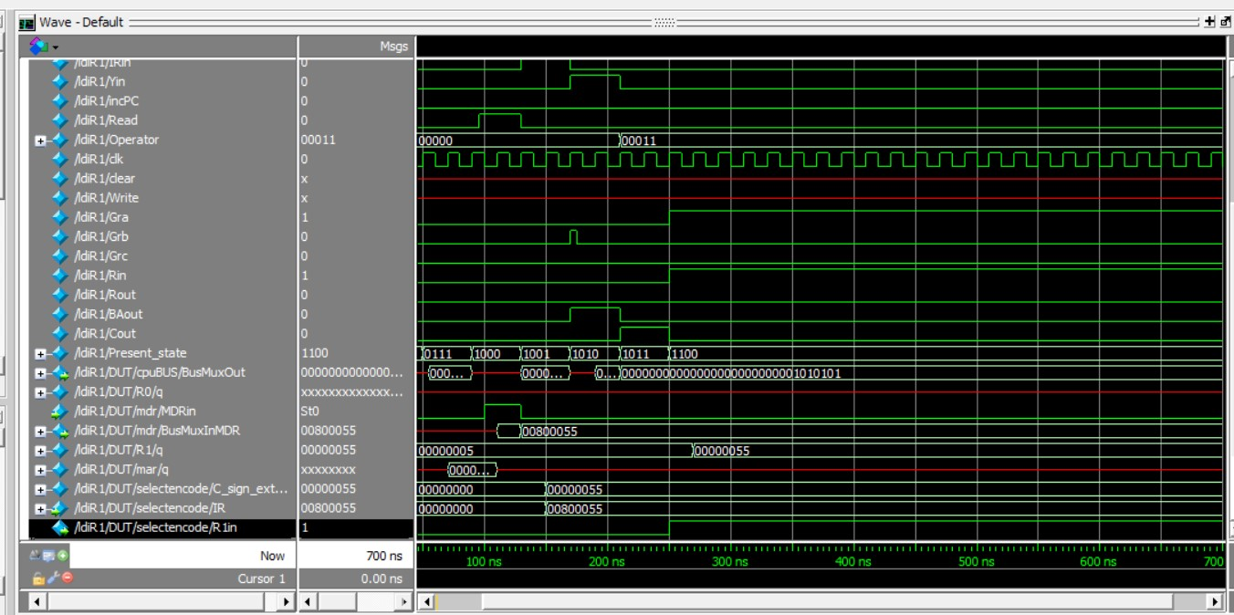

### Load Instruction – ldi R0, $35(R1)

This load instruction loads the immediate value that is the sum of the contents of R1 and 35. That is, the C sign extended value contains 0x23 (35) and R1 was preloaded with the value 5. To validate this test, we verified that R0 contained 0x28.

`timescale 1ns/10ps

module ldiR0;

reg PCout, Zlowout, MDRout, R2out, R4out;// add any other signals to see in your simulation

reg MARin, Zin, PCin, MDRin, IRin, Yin;

reg incPC, Read;

reg [4:0] Operator;

reg clk;

reg clear,Write;

reg Gra, Grb, Grc, Rin, Rout, BAout, Cout;

parameter Default = 4'b0000, T0= 4'b0111,T1= 4'b1000,T2= 4'b1001, T3= 4'b1010, T4= 4'b1011, T5= 4'b1100,T6= 4'b1101,T7= 4'b1110;

reg[3:0] Present_state= Default;

DataPath DUT(PCout, Zlowout, MDRout, MARin, Zin, PCin, MDRin, IRin, Yin, Read, Write, Operator, clk, clear,

Gra, Grb, Grc, Rin, Rout, BAout,Cout);

initial begin

clk = 0;

forever #10 clk = ~clk;

end

always @(posedge clk) //finite state machine; if clk rising-edge

begin

case (Present_state)

Default : #40 Present_state = T0;

T0 : #40 Present_state = T1;

T1 : #40 Present_state = T2;

T2 : #40 Present_state = T3;

T3 : #40 Present_state = T4;

T4 : #40 Present_state = T5;

endcase

end

always @(Present_state) // do the required job ineach state

begin

case (Present_state) //assert the required signals in each clk cycle

Default: begin

PCout <= 0; Zlowout <= 0; MDRout<= 0; //initialize the signals

MARin <= 0; Zin <= 0;

PCin <=0; MDRin <= 0; IRin <= 0; Yin <= 0;

incPC <= 0; Read <= 0; Operator <= 5'b00000;

Gra<= 0; Grb<= 0; Grc<= 0; Rin<= 0; Rout<= 0; BAout<= 0; Cout<=0;

clear <= 1; //initialize registers to 0

#10 clear <= 0;

end

T0: begin

//load value in PC register (0) in MAR

#5 PCout <= 1;

#5 MARin <= 1; //IncPC <= 1; Zin <= 1; used to inc PC by 4

end

T1: begin

//Zlowout <= 1; PCin <= 1;

PCout <= 0;

//MDR will grab value from ram @ address 0, this addess should contain instruction

#5 Read <= 1;

#5 MDRin <= 1;

end

T2: begin

Read <= 0;

MARin <= 0;

MDRin <= 0;

//load MDR value to bus which contains instruction, instruction is then stored in IR

MDRout<= 1; IRin <= 1;

end

T3: begin

MDRout<= 0;

IRin <= 0;

Grb <= 1;

//set to 1 to generate R1out = 1 and store value of R1 (5 hex) into Y register

BAout <= 1;

Yin <= 1;

#5 Grb <= 0;

end

T4: begin

BAout <= 0;

Yin <= 0;

//store C sign extended value on bus (should be 35 decimal)

Cout <=1;

//perform add between 35/BuxMuxOut + R1 (5)/BuxMuxInY

Operator <= 5'b00011;

//store result in Z register

Zin <=1;

end

//read from ram

T5: begin

Cout <= 0;

Zin <=0;

//store Z register contents (85) in bus

Zlowout <= 1;

Gra <= 1; //RA in Selectencode should be 0000 in binary

Rin <= 1;

end

//roin, r1out, y register, csignextended, z register, r1, r0

endcase

end

endmodule

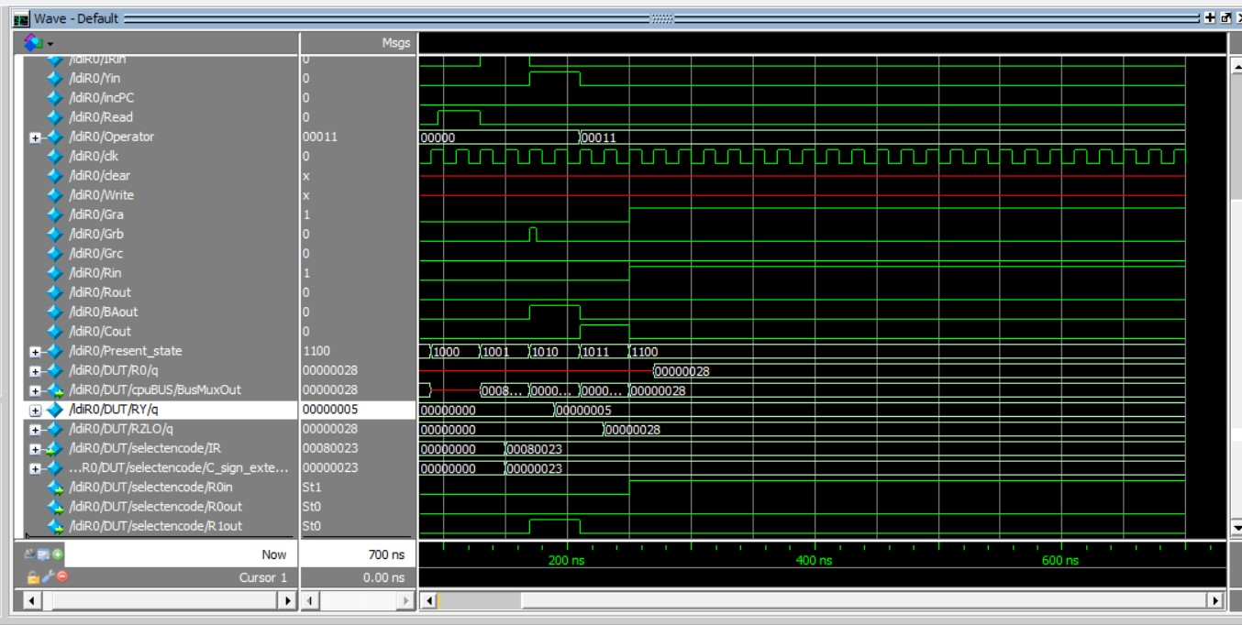

### Store Instruction – st $90, R1

This instruction verifies that the design can write the contents of R1 to the address 90 in ram. After loading the instruction into IR (T0-T2), the address is computed (90 + contents of R0 which are 0). Once the address is stored into the MAR and the value of R1 is transferred to MDR via the bus, the write signal is set to 1 to perform a memory write. Since R1 was preloaded with 5, we verified the memory contents at address 0x5A.

`timescale 1ns/10ps

module store;

reg PCout, Zlowout, MDRout, R2out, R4out;// add any other signals to see in your simulation

reg MARin, Zin, PCin, MDRin, IRin, Yin;

reg incPC, Read;

reg [4:0] Operator;

reg clk;

reg clear,Write;

reg Gra, Grb, Grc, Rin, Rout, BAout, Cout;

parameter Default = 4'b0000, T0= 4'b0111,T1= 4'b1000,T2= 4'b1001, T3= 4'b1010, T4= 4'b1011, T5= 4'b1100,T6= 4'b1101,T7= 4'b1110;

reg[3:0] Present_state= Default;

DataPath DUT(PCout, Zlowout, MDRout, MARin, Zin, PCin, MDRin, IRin, Yin, Read, Write, Operator, clk, clear,

Gra, Grb, Grc, Rin, Rout, BAout,Cout);

initial begin

clk = 0;

forever #10 clk = ~clk;

end

always @(posedge clk) //finite state machine; if clk rising-edge

begin

case (Present_state)

Default : #40 Present_state = T0;

T0 : #40 Present_state = T1;

T1 : #40 Present_state = T2;

T2 : #40 Present_state = T3;

T3 : #40 Present_state = T4;

T4 : #40 Present_state = T5;

T5 : #40 Present_state = T6;

T6 : #40 Present_state = T7;

endcase

end

always @(Present_state) // do the required job ineach state

begin

case (Present_state) //assert the required signals in each clk cycle

Default: begin

PCout <= 0; Zlowout <= 0; MDRout<= 0; //initialize the signals

MARin <= 0; Zin <= 0;

PCin <=0; MDRin <= 0; IRin <= 0; Yin <= 0;

incPC <= 0; Read <= 0; Operator <= 5'b00000;

Gra<= 0; Grb<= 0; Grc<= 0; Rin<= 0; Rout<= 0; BAout<= 0; Cout<=0;

clear <= 0;

end

T0: begin

//load value in PC register (0) in MAR

#5 PCout <= 1;

#5 MARin <= 1; //IncPC <= 1; Zin <= 1; used to inc PC by 4

end

T1: begin

//Zlowout <= 1; PCin <= 1;

PCout <= 0;

//MDR will grab value from ram @ address 0, this addess should contain instruction

#5 Read <= 1;

#5 MDRin <= 1;

end

T2: begin

Read <= 0;

MARin <= 0;

MDRin <= 0;

//load MDR value to bus which contains instruction, instruction is then stored in IR

MDRout<= 1; IRin <= 1;

end

T3: begin

MDRout<= 0;

IRin <= 0;

//select R0out since Rb = 0000

Grb <= 1;

//set to 1 to generate R0out = 1 and store value of R0 (0 hex) into Y register

BAout <= 1;

Yin <= 1;

#5 Grb <= 0;

end

T4: begin

BAout <= 0;

Yin <= 0;

//store C sign extended value on bus (should be 90 decimal)

Cout <=1;

//perform add between 90/BuxMuxOut + R0 (0)/BuxMuxInY

Operator <= 5'b00011;

//store result in Z register

Zin <=1;

end

T5: begin

Cout <= 0;

Zin <=0;

//store Z register contents (85) in bus

Zlowout <= 1;

//load 90/busMuxOut into MAR to get address of 85

MARin <= 1;

end

T6: begin

Zlowout <=0;

MARin<=0;

Gra <= 1; //RA in Selectencode should be 0001 in binary

BAout <= 1;

MDRin <= 1; //load value of 85 from R1 to MDR

end

T7: begin

MDRin <= 0;

Gra <= 0;

BAOut <=0;

Write <= 1;

end

endcase

end

endmodule

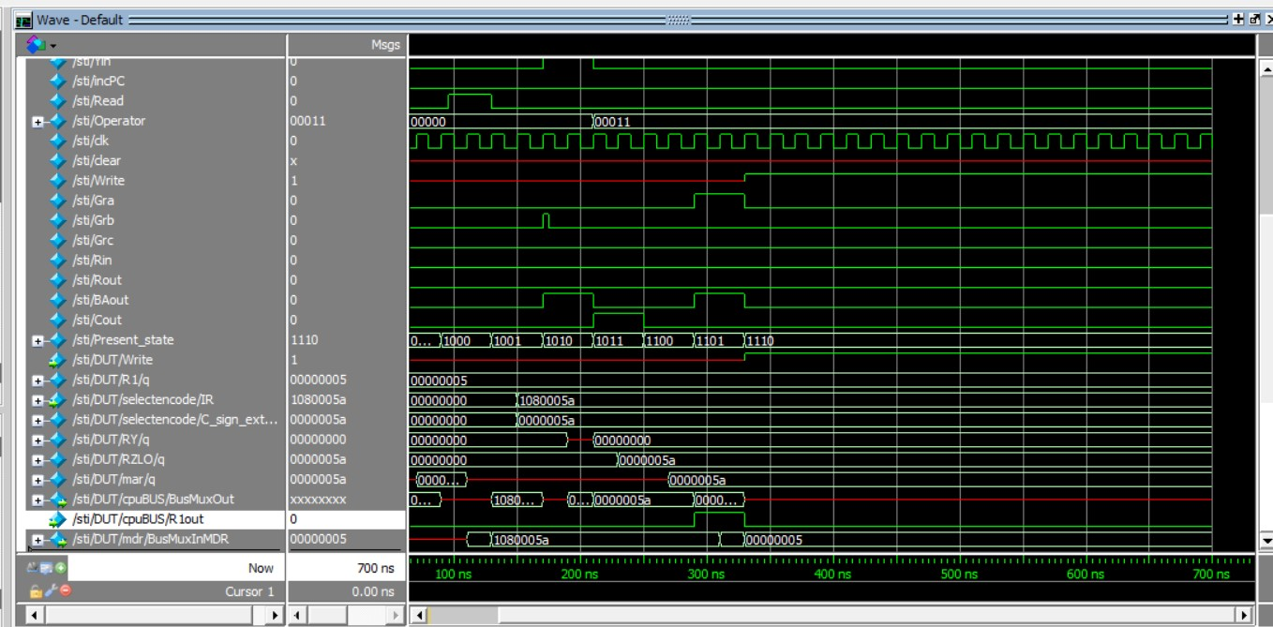

### Store Instruction – st $90(R1), R1

This instruction follows the same steps as the previous test except that the address is calculated by adding 90 with the value stored in R1 (5). Therefore, we verified that 5 was written at address 0x5f.

`timescale 1ns/10ps

module storeidx;

reg PCout, Zlowout, MDRout, R2out, R4out;// add any other signals to see in your simulation

reg MARin, Zin, PCin, MDRin, IRin, Yin;

reg incPC, Read;

reg [4:0] Operator;

reg clk;

reg clear,Write;

reg Gra, Grb, Grc, Rin, Rout, BAout, Cout;

parameter Default = 4'b0000, T0= 4'b0111,T1= 4'b1000,T2= 4'b1001, T3= 4'b1010, T4= 4'b1011, T5= 4'b1100,T6= 4'b1101,T7= 4'b1110;

reg[3:0] Present_state= Default;

DataPath DUT(PCout, Zlowout, MDRout, MARin, Zin, PCin, MDRin, IRin, Yin, Read, Write, Operator, clk, clear,

Gra, Grb, Grc, Rin, Rout, BAout,Cout);

initial begin

clk = 0;

forever #10 clk = ~clk;

end

always @(posedge clk) //finite state machine; if clk rising-edge

begin

case (Present_state)

Default : #40 Present_state = T0;

T0 : #40 Present_state = T1;

T1 : #40 Present_state = T2;

T2 : #40 Present_state = T3;

T3 : #40 Present_state = T4;

T4 : #40 Present_state = T5;

T5 : #40 Present_state = T6;

T6 : #40 Present_state = T7;

endcase

end

always @(Present_state) // do the required job ineach state

begin

case (Present_state) //assert the required signals in each clk cycle

Default: begin

PCout <= 0; Zlowout <= 0; MDRout<= 0; //initialize the signals

MARin <= 0; Zin <= 0;

PCin <=0; MDRin <= 0; IRin <= 0; Yin <= 0;

incPC <= 0; Read <= 0; Operator <= 5'b00000;

Gra<= 0; Grb<= 0; Grc<= 0; Rin<= 0; Rout<= 0; BAout<= 0; Cout<=0;

clear <= 0;

end

T0: begin

//load value in PC register (0) in MAR

#5 PCout <= 1;

#5 MARin <= 1; //IncPC <= 1; Zin <= 1; used to inc PC by 4

end

T1: begin

//Zlowout <= 1; PCin <= 1;

PCout <= 0;

//MDR will grab value from ram @ address 0, this addess should contain instruction

#5 Read <= 1;

#5 MDRin <= 1;

end

T2: begin

Read <= 0;

MARin <= 0;

MDRin <= 0;

//load MDR value to bus which contains instruction, instruction is then stored in IR

MDRout<= 1; IRin <= 1;

end

T3: begin

MDRout<= 0;

IRin <= 0;

//select R1out since Rb = 0001

Grb <= 1;

//set to 1 to generate R1out = 1 and store value of R1 (85 hex) into Y register

BAout <= 1;

Yin <= 1;

#5 Grb <= 0;

end

T4: begin

BAout <= 0;

Yin <= 0;

//store C sign extended value on bus (should be 90 decimal)

Cout <=1;

//perform add between 90/BuxMuxOut + R1 (85)/BuxMuxInY

Operator <= 5'b00011;

//store result in Z register

Zin <=1;

end

T5: begin

Cout <= 0;

Zin <=0;

//store Z register contents (85) in bus

Zlowout <= 1;

//load 90/busMuxOut into MAR to get address of 85

MARin <= 1;

end

T6: begin

Zlowout <=0;

MARin<=0;

Grb <= 1; //RA in Selectencode should be 0001 in binary

BAout <= 1;

MDRin <= 1; //load value of 85 from R1 to MDR

end

T7: begin

MDRin <= 0;

Grb <= 0;

BAOut <=0;

Write <= 1;

end

endcase

end

endmodule

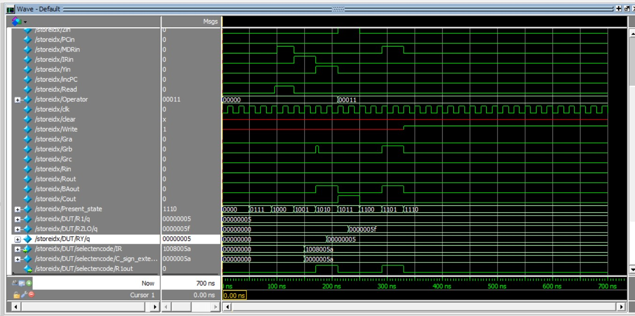

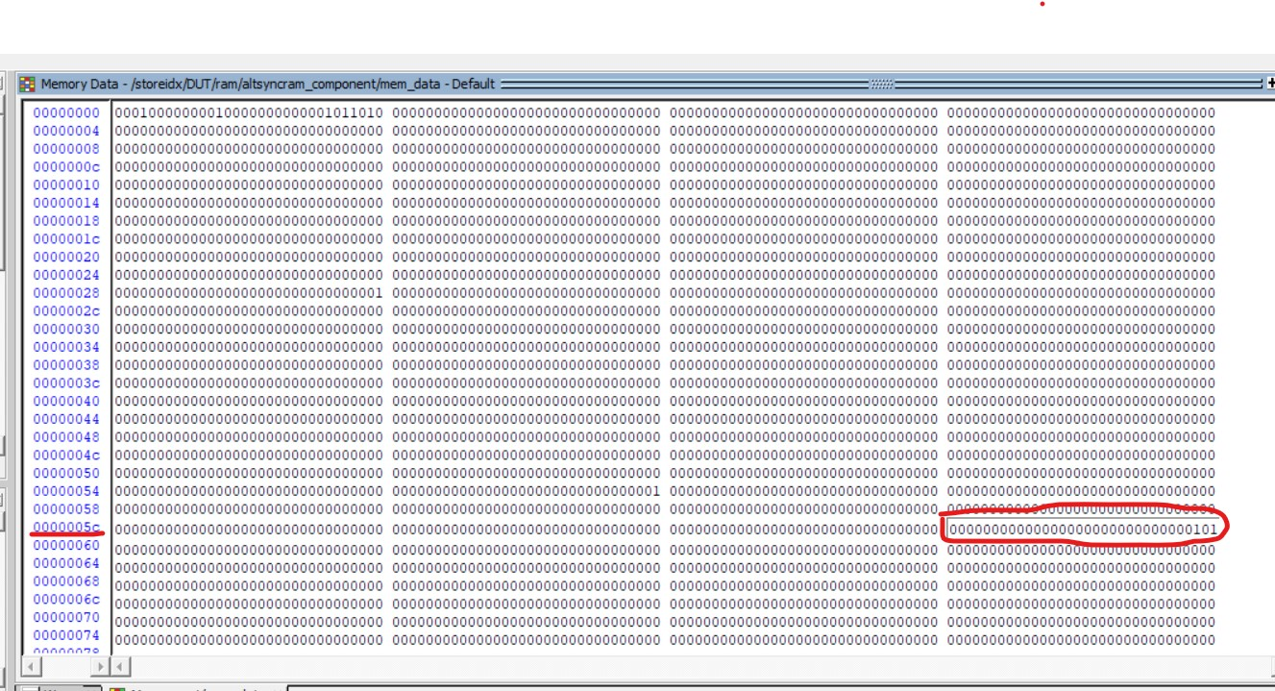

### Verify Jump Case

Here we are verifying the functionality of the jr instruction by simulating the control sequence for jr R1. Note that R1 was preloaded with the value 5.

`timescale 1ns/10ps

module TBjumpcase;

    reg PCout, Zlowout, MDRout, R2out, R4out;// add any other signals to see in your simulation

    reg MARin, Zin, PCin, MDRin, IRin, Yin;

    reg incPC, Read;

     reg [4:0] Operator;

    reg clk;

     reg clear, Write;

    reg Gra, Grb, Grc, Rin, Rout, BAout, Cout, ConIn;

    parameter   Default = 4'b0000, T0= 4'b0111,T1= 4'b1000,T2= 4'b1001, T3= 4'b1010, T4= 4'b1011, T5= 4'b1100,T6= 4'b1101,T7= 4'b1110;

    reg[3:0] Present_state= Default;

DataPath DUT(PCout, Zlowout, MDRout, MARin, Zin, PCin, MDRin, IRin, Yin, Read, Write, Operator, clk, clear,

Gra, Grb, Grc, Rin, Rout, BAout, Cout, ConIn);

initial begin

    clk = 0;

    forever #10 clk = ~clk;

end

always @(posedge clk)     //finite state machine; if clk rising-edge

    begin

        case (Present_state)

            Default     :   #40 Present_state = T0;

            T0          :   #40 Present_state = T1;

            T1          :   #40 Present_state = T2;

            T2          :   #40 Present_state = T3;

            T3          :   #40 Present_state = T4;

            T4          :   #40 Present_state = T5;

            T5          :   #40 Present_state = T6;

            T6          :   #40 Present_state = T7;

        endcase

    end

always @(Present_state)     // do the required job ineach state

    begin

        case (Present_state)              //assert the required signals in each clk cycle

            Default: begin

                PCout <= 0;   Zlowout <= 0;   MDRout<= 0;   //initialize the signals

                MARin <= 0;   Zin <= 0;

                PCin <= 0;   MDRin <= 0;   IRin  <= 0;   Yin <= 0;

                incPC <= 0;   Read <= 0;   Operator <= 5'b00000;

                Gra<= 0; Grb <= 0; Grc <= 0; Rin <= 0; Rout <= 0; BAout <= 0; Cout <= 0;

                // clear <= 1; //initialize registers to 0

                     clear <= 0;

            end

            T0: begin

                //load value in PC register (0) in MAR

                #5 PCout <= 1;

                     #5 MARin <= 1;  //IncPC <= 1; Zin <= 1; used to inc PC by 4

            end

            T1: begin

                //Zlowout <= 1; PCin <= 1;

                PCout <= 0;

                     MARin <= 0;

                //MDR will grab value from ram @ address 0, this addess should contain instruction

                #5 Read <= 1;

                     #5 MDRin <= 1;

            end

            T2: begin

                Read <= 0;

                MARin <= 0;

                MDRin <= 0;

                //load MDR value to bus which contains instruction, instruction is then stored in IR

                MDRout <= 1; IRin <= 1;

            end

            T3: begin

                     MDRout <= 0;

                     IRin <= 0;

                Gra <= 1;

                Rout <= 1;

                PCin <= 1;

                     BAout <= 1;

            end

        endcase

    end

endmodule

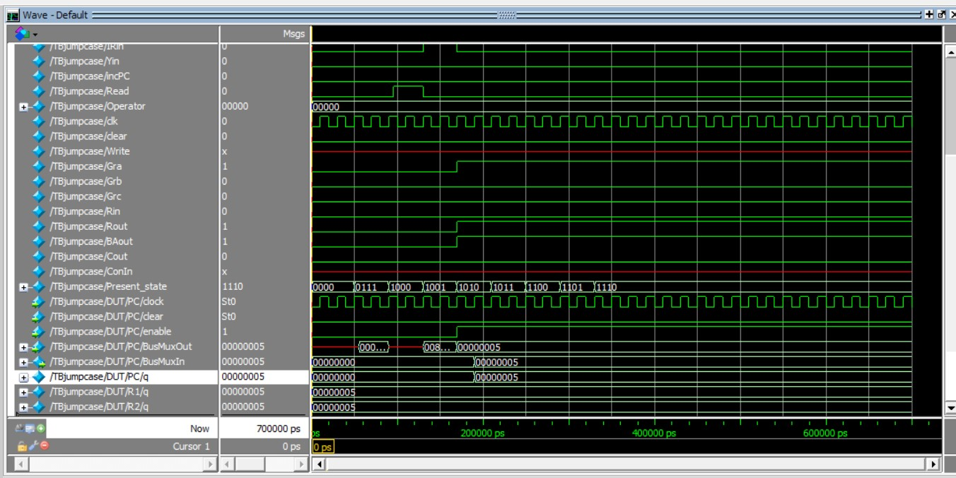

### Mfhi & mflo

Here we are verifying the functionality by simulating the control sequences for mfhi R1 and mflo R1. Note that R1 was preloaded with the value 5.

`timescale 1ns/10ps

module TBmfhiandlo;

    reg PCout, Zlowout, MDRout, R2out, R4out;// add any other signals to see in your simulation

    reg MARin, Zin, PCin, MDRin, IRin, Yin;

    reg incPC, Read;

     reg [4:0] Operator;

    reg clk;

     reg clear,Write;

    reg Gra, Grb, Grc, Rin, Rout, BAout, Cout, ConIn, HIout;

    parameter   Default = 4'b0000, T0= 4'b0111,T1= 4'b1000,T2= 4'b1001, T3= 4'b1010, T4= 4'b1011, T5= 4'b1100,T6= 4'b1101,T7= 4'b1110;

    reg[3:0] Present_state= Default;

DataPath DUT(PCout, Zlowout, MDRout, MARin, Zin, PCin, MDRin, IRin, Yin, Read, Write, Operator, clk, clear,

Gra, Grb, Grc, Rin, Rout, BAout, Cout, ConIn, HIout);

initial begin

    clk = 0;

    forever #10 clk = ~clk;

end

always @(posedge clk)     //finite state machine; if clk rising-edge

    begin

        case (Present_state)

            Default     :   #40 Present_state = T0;

            T0          :   #40 Present_state = T1;

            T1          :   #40 Present_state = T2;

            T2          :   #40 Present_state = T3;

            T3          :   #40 Present_state = T4;

            T4          :   #40 Present_state = T5;

            T5          :   #40 Present_state = T6;

            T6          :   #40 Present_state = T7;

        endcase

    end

always @(Present_state)     // do the required job ineach state

    begin

        case (Present_state)              //assert the required signals in each clk cycle

            Default: begin

                PCout <= 0;   Zlowout <= 0;   MDRout<= 0;   //initialize the signals

                MARin <= 0;   Zin <= 0;

                PCin <=0;   MDRin <= 0;   IRin  <= 0;   Yin <= 0;

                //IncPC <= 0;

                     Read <= 0;   Operator <= 5'b00000;

                Gra<= 0; Grb<= 0; Grc<= 0; Rin<= 0; Rout<= 0; BAout<= 0; Cout<=0;

                     #10 clear <= 0; HIout <= 0;

            end

            T0: begin

                //load value in PC register (0) in MAR

                #5 PCout <= 1;

                     #5 MARin <= 1;  //IncPC <= 1; Zin <= 1; used to inc PC by 4

            end

            T1: begin

                //Zlowout <= 1; PCin <= 1;

                PCout <= 0;

                     MARin <= 0;

                //MDR will grab value from ram @ address 0, this addess should contain instruction

                #5 Read <= 1;

                     #5 MDRin <= 1;

            end

            T2: begin

                Read <= 0;

                MARin <= 0;

                MDRin <= 0;

                //load MDR value to bus which contains instruction, instruction is then stored in IR

                MDRout<= 1; IRin <= 1;

            end

            T3: begin

                     MDRout <= 0;

                     IRin <= 0;

                Read <= 0;

                MDRin <= 0;

                //load value in MDR on Bus

                     HIout <= 1;

                //set R1in signal to 1, value that was in memory at address 85 should now be stored in R1

                Gra <= 1;  //RA in Selectencode should be 0001 in binary

                Rin <= 1;

            end

        endcase

    end

endmodule

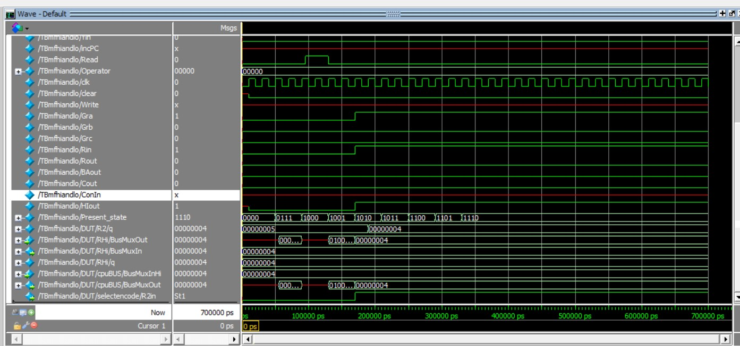

### In/Out

Here we are verifying the functionality of our Output Port logic by simulating the control sequence for out R1. Note that R1 was preloaded with the value 5.

`timescale 1ns/10ps

module TBinout;

    reg PCout, Zlowout, MDRout, R2out, R4out;// add any other signals to see in your simulation

    reg MARin, Zin, PCin, MDRin, IRin, Yin;

    reg incPC, Read;

     reg [4:0] Operator;

    reg clk;

     reg clear,Write;

    reg Gra, Grb, Grc, Rin, Rout, BAout, Cout, ConIn, RoutPIn;

    parameter   Default = 4'b0000, T0= 4'b0111,T1= 4'b1000,T2= 4'b1001, T3= 4'b1010, T4= 4'b1011, T5= 4'b1100,T6= 4'b1101,T7= 4'b1110;

    reg[3:0] Present_state= Default;

DataPath DUT(PCout, Zlowout, MDRout, MARin, Zin, PCin, MDRin, IRin, Yin, Read, Write, Operator, clk, clear,

Gra, Grb, Grc, Rin, Rout, BAout, Cout, ConIn, RoutPIn);

initial begin

    clk = 0;

    forever #10 clk = ~clk;

end

always @(posedge clk)     //finite state machine; if clk rising-edge

    begin

        case (Present_state)

            Default     :   #40 Present_state = T0;

            T0          :   #40 Present_state = T1;

            T1          :   #40 Present_state = T2;

            T2          :   #40 Present_state = T3;

            T3          :   #40 Present_state = T4;

            T4          :   #40 Present_state = T5;

            T5          :   #40 Present_state = T6;

            T6          :   #40 Present_state = T7;

        endcase

    end

always @(Present_state)     // do the required job ineach state

    begin

        case (Present_state)              //assert the required signals in each clk cycle

            Default: begin

                PCout <= 0;   Zlowout <= 0;   MDRout<= 0;   //initialize the signals

                MARin <= 0;   Zin <= 0;

                PCin <=0;   MDRin <= 0;   IRin  <= 0;   Yin <= 0;

                incPC <= 0;   Read <= 0;   Operator <= 5'b00000;

                Gra<= 0; Grb<= 0; Grc<= 0; Rin<= 0; Rout<= 0; BAout<= 0; Cout<=0;

                // clear <= 1; //initialize registers to 0

                     // #10 clear <= 0;

            end

            T0: begin

                //load value in PC register (0) in MAR

                #5 PCout <= 1;

                     #5 MARin <= 1;  //IncPC <= 1; Zin <= 1; used to inc PC by 4

            end

            T1: begin

                //Zlowout <= 1; PCin <= 1;

                PCout <= 0;

                //MDR will grab value from ram @ address 0, this addess should contain instruction

                #5 Read <= 1;

                     #5 MDRin <= 1;

            end

            T2: begin

                Read <= 0;

                MARin <= 0;

                MDRin <= 0;

                //load MDR value to bus which contains instruction, instruction is then stored in IR

                MDRout<= 1; IRin <= 1;

            end

            T3: begin

                     MDRout <= 0;

                     IRin <= 0;

                Gra <= 1;

                Rout <= 1;

                RoutPIn <= 1;

            end

        endcase

    end

endmodule

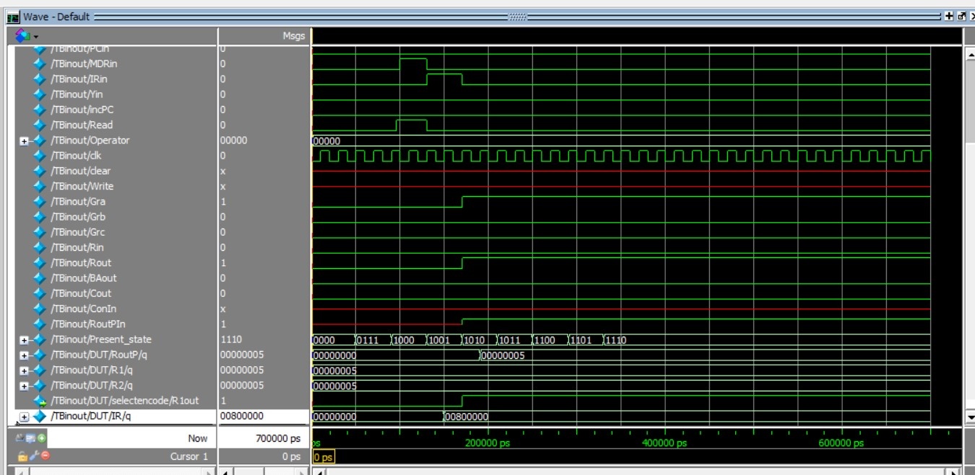

### Addi instruction – R2, R1, -5

This instruction verifies that the design can subtract 5 from the contents of R1 and store the result in R2. First the instruction into IR (T0-T2), then the add operation is performed. The result is stored in RZLo and then moved into the destination register, R2.

// Op-code: 31-27, Ra: 26-23, C2: 22-19, C: 18-0

`timescale 1ns/10ps

module addi_tb;

reg PCout, Zlowout, MDRout; // add any other signals to see in your simulation

reg MARin, Zin, PCin, MDRin, IRin, Yin;

reg incPC, Read;

reg [4:0] Operator;

reg clk;

reg clear, Write;

reg Gra, Grb, Grc, Rin, Rout, BAout, Cout, ConIn;

parameter Default = 4'b0000, T0= 4'b0111,T1= 4'b1000,T2= 4'b1001, T3= 4'b1010, T4= 4'b1011, T5= 4'b1100,T6= 4'b1101,T7= 4'b1110;

reg[3:0] Present_state= Default;

DataPath DUT(PCout, Zlowout, MDRout, MARin, Zin, PCin, MDRin, IRin, Yin, Read, Write, Operator, clk, clear,

Gra, Grb, Grc, Rin, Rout, BAout,Cout, ConIn);

initial begin

clk = 0;

forever #10 clk = ~clk;

end

always @(posedge clk) //finite state machine; if clk rising-edge

begin

case (Present_state)

Default : #40 Present_state = T0;

T0 : #40 Present_state = T1;

T1 : #40 Present_state = T2;

T2 : #40 Present_state = T3;

T3 : #40 Present_state = T4;

T4 : #40 Present_state = T5;

T5 : #40 Present_state = T6;

T6 : #40 Present_state = T7;

endcase

end

always @(Present_state) // do the required job ineach state

begin

case (Present_state) //assert the required signals in each clk cycle

Default: begin

PCout <= 0; Zlowout <= 0; MDRout<= 0; //initialize the signals

MARin <= 0; Zin <= 0;

PCin <=0; MDRin <= 0; IRin <= 0; Yin <= 0;

incPC <= 0; Read <= 0; Operator <= 5'b00000;

Gra <= 0; Grb <= 0; Grc <= 0; Rin <= 0; Rout <= 0; BAout <= 0; Cout <=0;

// clear <= 1; //initialize registers to 0

// #10 clear <= 0;

end

T0: begin

//load value in PC register (0) in MAR

#5 PCout <= 1;

#5 MARin <= 1; //IncPC <= 1; Zin <= 1; used to inc PC by 4

// incPC <= 1;

// Zin <= 1;

end

T1: begin

// Zlowout <= 1; PCin <= 1;

PCout <= 0;

//MDR will grab value from ram @ address 0, this addess should contain instruction

#5 Read <= 1; // Mdatain <= 1;

#5 MDRin <= 1;

end

T2: begin

Read <= 0;

MARin <= 0;

MDRin <= 0;

//load MDR value to bus which contains instruction, instruction is then stored in IR

MDRout<= 1; IRin <= 1;

end

T3: begin

MDRout<= 0;

IRin <= 0;

//select R0out since Rb = 0000

Grb <= 1;

//set to 1 to generate R0out = 1 and store value of R0 (0) into Y register

Rout <= 1;

Yin <= 1;

#5 Grb <= 0;

end

T4: begin

Rout <= 0;

Yin <= 0;

//store C sign extended value on bus (should be 85 decimal)

Cout <= 1;

//perform add between 85/BuxMuxOut + R0 (0)/BuxMuxInY

Operator <= 5'b00011; // Add

//store result in Z register

Zin <=1;

end

//read from ram

T5: begin

Cout <= 0;

Zin <=0;

// Grb <= 0;

//store Z register contents (85) in bus

Zlowout <= 1;

Gra <= 1;

//load 85/busMuxOut into MAR to get address of 85

Rin <= 1;

end

endcase

end

endmodule

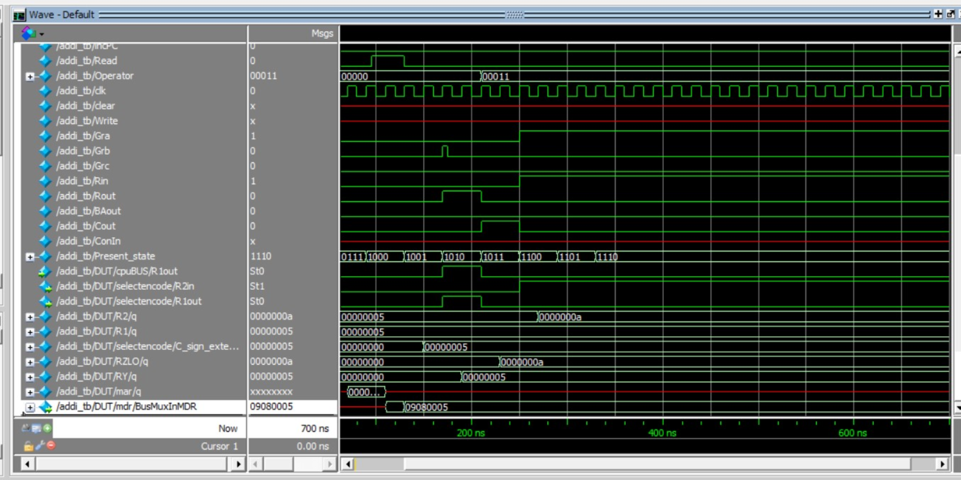

### Andi instruction – andi R2, R1, $26

This instruction shows that the design can perform an and immediate operation on $26 and the value of R1, then subsequently store the result in R2. The steps T0-T2 are executed first, performing the fetch instruction. The andi immediate instruction is performed and stored in the RZLo and moved to the appropriate destination register, R2.

`timescale 1ns/10ps

module andi_tb;

reg PCout, Zlowout, MDRout; // add any other signals to see in your simulation

reg MARin, Zin, PCin, MDRin, IRin, Yin;

reg incPC, Read;

reg [4:0] Operator;

reg clk;

reg clear, Write;

reg Gra, Grb, Grc, Rin, Rout, BAout, Cout, ConIn;

parameter Default = 4'b0000, T0= 4'b0111,T1= 4'b1000,T2= 4'b1001, T3= 4'b1010, T4= 4'b1011, T5= 4'b1100,T6= 4'b1101,T7= 4'b1110;

reg[3:0] Present_state= Default;

DataPath DUT(PCout, Zlowout, MDRout, MARin, Zin, PCin, MDRin, IRin, Yin, Read, Write, Operator, clk, clear,

Gra, Grb, Grc, Rin, Rout, BAout,Cout, ConIn);

initial begin

clk = 0;

forever #10 clk = ~clk;

end

always @(posedge clk) //finite state machine; if clk rising-edge

begin

case (Present_state)

Default : #40 Present_state = T0;

T0 : #40 Present_state = T1;

T1 : #40 Present_state = T2;

T2 : #40 Present_state = T3;

T3 : #40 Present_state = T4;

T4 : #40 Present_state = T5;

T5 : #40 Present_state = T6;

T6 : #40 Present_state = T7;

endcase

end

always @(Present_state) // do the required job ineach state

begin

case (Present_state) //assert the required signals in each clk cycle

Default: begin

PCout <= 0; Zlowout <= 0; MDRout<= 0; //initialize the signals

MARin <= 0; Zin <= 0;

PCin <=0; MDRin <= 0; IRin <= 0; Yin <= 0;

incPC <= 0; Read <= 0; Operator <= 5'b00000;

Gra <= 0; Grb <= 0; Grc <= 0; Rin <= 0; Rout <= 0; BAout <= 0; Cout <=0;

// clear <= 1; //initialize registers to 0

// #10 clear <= 0;

end

T0: begin

//load value in PC register (0) in MAR

#5 PCout <= 1;

#5 MARin <= 1; //IncPC <= 1; Zin <= 1; used to inc PC by 4

// incPC <= 1;

// Zin <= 1;

end

T1: begin

// Zlowout <= 1; PCin <= 1;

PCout <= 0;

//MDR will grab value from ram @ address 0, this addess should contain instruction

#5 Read <= 1; // Mdatain <= 1;

#5 MDRin <= 1;

end

T2: begin

Read <= 0;

MARin <= 0;

MDRin <= 0;

//load MDR value to bus which contains instruction, instruction is then stored in IR

MDRout<= 1; IRin <= 1;

end

T3: begin

MDRout<= 0;

IRin <= 0;

//select R0out since Rb = 0000

Grb <= 1;

//set to 1 to generate R0out = 1 and store value of R0 (0) into Y register

Rout <= 1;

Yin <= 1;

#5 Grb <= 0;

end

T4: begin

Rout <= 0;

Yin <= 0;

//store C sign extended value on bus (should be 85 decimal)

Cout <= 1;

//perform add between 85/BuxMuxOut + R0 (0)/BuxMuxInY

Operator <= 5'b00011; // Add

//store result in Z register

Zin <=1;

end

//read from ram

T5: begin

Cout <= 0;

Zin <=0;

// Grb <= 0;

//store Z register contents (85) in bus

Zlowout <= 1;

Gra <= 1;

//load 85/busMuxOut into MAR to get address of 85

Rin <= 1;

end

endcase

end

endmodule

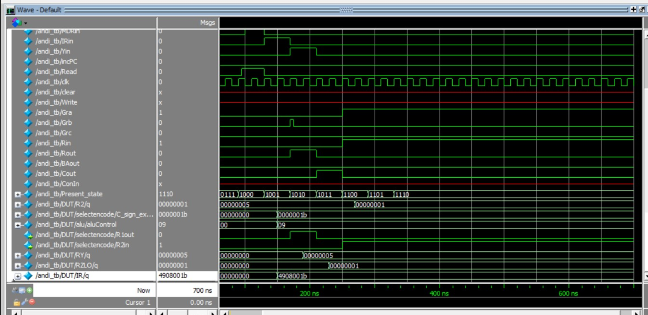

### Ori instruction – ori R2, R1, $26

This instruction shows that the design can perform an or immediate operation on $26 and the value of R1, then subsequently store the result in R2. The steps T0-T2 are executed first, performing the fetch instruction. The or immediate instruction is performed and stored in the RZLo and moved to the appropriate destination register, R2.

`timescale 1ns/10ps

module ori_tb;

reg PCout, Zlowout, MDRout; // add any other signals to see in your simulation

reg MARin, Zin, PCin, MDRin, IRin, Yin;

reg incPC, Read;

reg [4:0] Operator;

reg clk;

reg clear, Write;

reg Gra, Grb, Grc, Rin, Rout, BAout, Cout, ConIn;

parameter Default = 4'b0000, T0= 4'b0111,T1= 4'b1000,T2= 4'b1001, T3= 4'b1010, T4= 4'b1011, T5= 4'b1100,T6= 4'b1101,T7= 4'b1110;

reg[3:0] Present_state= Default;

DataPath DUT(PCout, Zlowout, MDRout, MARin, Zin, PCin, MDRin, IRin, Yin, Read, Write, Operator, clk, clear,

Gra, Grb, Grc, Rin, Rout, BAout,Cout, ConIn);

initial begin

clk = 0;

forever #10 clk = ~clk;

end

always @(posedge clk) //finite state machine; if clk rising-edge

begin

case (Present_state)

Default : #40 Present_state = T0;

T0 : #40 Present_state = T1;

T1 : #40 Present_state = T2;

T2 : #40 Present_state = T3;

T3 : #40 Present_state = T4;

T4 : #40 Present_state = T5;

T5 : #40 Present_state = T6;

T6 : #40 Present_state = T7;

endcase

end

always @(Present_state) // do the required job ineach state

begin

case (Present_state) //assert the required signals in each clk cycle

Default: begin

PCout <= 0; Zlowout <= 0; MDRout<= 0; //initialize the signals

MARin <= 0; Zin <= 0;

PCin <=0; MDRin <= 0; IRin <= 0; Yin <= 0;

incPC <= 0; Read <= 0; Operator <= 5'b00000;

Gra <= 0; Grb <= 0; Grc <= 0; Rin <= 0; Rout <= 0; BAout <= 0; Cout <=0;

// clear <= 1; //initialize registers to 0

// #10 clear <= 0;

end

T0: begin

//load value in PC register (0) in MAR

#5 PCout <= 1;

#5 MARin <= 1; //IncPC <= 1; Zin <= 1; used to inc PC by 4

// incPC <= 1;

// Zin <= 1;

end

T1: begin

// Zlowout <= 1; PCin <= 1;

PCout <= 0;

//MDR will grab value from ram @ address 0, this addess should contain instruction

#5 Read <= 1; // Mdatain <= 1;

#5 MDRin <= 1;

end

T2: begin

Read <= 0;

MARin <= 0;

MDRin <= 0;

//load MDR value to bus which contains instruction, instruction is then stored in IR

MDRout<= 1; IRin <= 1;

end

T3: begin

MDRout<= 0;

IRin <= 0;

//select R0out since Rb = 0000

Grb <= 1;

//set to 1 to generate R0out = 1 and store value of R0 (0) into Y register

Rout <= 1;

Yin <= 1;

#5 Grb <= 0;

end

T4: begin

Rout <= 0;

Yin <= 0;

//store C sign extended value on bus (should be 85 decimal)

Cout <= 1;

//perform add between 85/BuxMuxOut + R0 (0)/BuxMuxInY

Operator <= 5'b00011; // Add

//store result in Z register

Zin <=1;

end

//read from ram

T5: begin

Cout <= 0;

Zin <=0;

// Grb <= 0;

//store Z register contents (85) in bus

Zlowout <= 1;

Gra <= 1;

//load 85/busMuxOut into MAR to get address of 85

Rin <= 1;

end

endcase

end

endmodule



### Brzr instruction – brzr R2, 35

This instruction shows that the design can perform a brzr branch (branch if zero) operation on 35 and the value of R2. The steps T0-T2 are executed first, performing the fetch instruction. Then, an operation is performed to determine whether or not to branch. If required, the branch is then performed.

// make tbs for:

// branch instructions: brzr, brnz, brpl, brmi

// Op-code: 31-27, Ra: 26-23, C2: 22-19, C: 18-0

// brzr: 0108 0023, C2: 0001

// 0 0000, 0010, 0001, 000 0000 0000 0010 0011

// brnz: 0110 0023, C2: 0010

// 0 0000, 0010, 0010, 000 0000 0000 0010 0011

// brpl: 0120 0023, C2: 0100

// brmi: 0140 0023, C2: 1000

`timescale 1ns/10ps

module branch_tb;

reg PCout, Zlowout, MDRout, R2out, R4out;// add any other signals to see in your simulation

reg MARin, Zin, PCin, MDRin, IRin, Yin;

reg Read;

reg [4:0] Operator;

reg clk;

reg clear, Write;

reg Gra, Grb, Grc, Rin, Rout, BAout, Cout;

reg ConIn;

parameter Default = 4'b0000, T0= 4'b0111, T1= 4'b1000, T2= 4'b1001, T3= 4'b1010, T4= 4'b1011, T5= 4'b1100, T6= 4'b1101;

reg[3:0] Present_state= Default;

DataPath DUT(PCout, Zlowout, MDRout, MARin, Zin, PCin, MDRin, IRin, Yin, Read, Write, Operator, clk, clear,

Gra, Grb, Grc, Rin, Rout, BAout, Cout, ConIn);

initial begin

clk = 0;

forever #10 clk = ~clk;

end

always @(posedge clk) //finite state machine; if clk rising-edge

begin

case (Present_state)

Default : #40 Present_state = T0;

T0 : #40 Present_state = T1;

T1 : #40 Present_state = T2;

T2 : #40 Present_state = T3;

T3 : #40 Present_state = T4;

T4 : #40 Present_state = T5;

T5 : #40 Present_state = T6;

endcase

end

always @(Present_state) // do the required job ineach state

begin

case (Present_state) //assert the required signals in each clk cycle

Default: begin

PCout <= 0; Zlowout <= 0; MDRout<= 0; //initialize the signals

MARin <= 0; Zin <= 0;

PCin <=0; MDRin <= 0; IRin <= 0; Yin <= 0;

// incPC <= 0;

Read <= 0; Operator <= 5'b00000;

Gra<= 0; Grb<= 0; Grc<= 0; Rin<= 0; Rout<= 0; BAout<= 0; Cout<=0;

// clear <= 1; //initialize registers to 0

//#10 clear <= 0;

end

T0: begin

//load value in PC register (0) in MAR

#5 PCout <= 1;

#5 MARin <= 1; //IncPC <= 1; Zin <= 1; used to inc PC by 4

// incPC <= 1;

// Zin <= 1;

end

T1: begin

// Zlowout <= 1; PCin <= 1;

PCout <= 0;

//MDR will grab value from ram @ address 0, this addess should contain instruction

#5 Read <= 1; // Mdatain <= 1;

#5 MDRin <= 1;

end

T2: begin

Read <= 0;

MARin <= 0;

MDRin <= 0;

//load MDR value to bus which contains instruction, instruction is then stored in IR

MDRout<= 1; IRin <= 1;

end

T3: begin

MDRout<= 0;

IRin <= 0;

Gra <= 1;

Rout <= 1;

ConIn <= 1;

//set to 1 to generate R0out = 1 and store value of R0 (0) into Y register

#5 Gra <= 0;

end

T4: begin

Rout <= 0;

ConIn <= 0;

PCout <= 1; Yin <= 1;

end

T5: begin

PCout <= 0; Yin <= 0;

Cout <= 1;

Operator <= 5'b00011; // ADD

Zin <= 1;

// store Z register contents (85) in bus

// Zlowout <= 1;

// load 85/busMuxOut into MAR to get address of 85

// MARin <= 1;

end

T6: begin

Cout <= 0;

Zin <= 0;

Zlowout <= 1;

// PC <= Con;

// read from ram at address 85 and load that value in MDR -> we will need to have a preset value in memory at address 85

// Read <= 1;

// MDRin <= 1;

end

endcase

end

endmodule

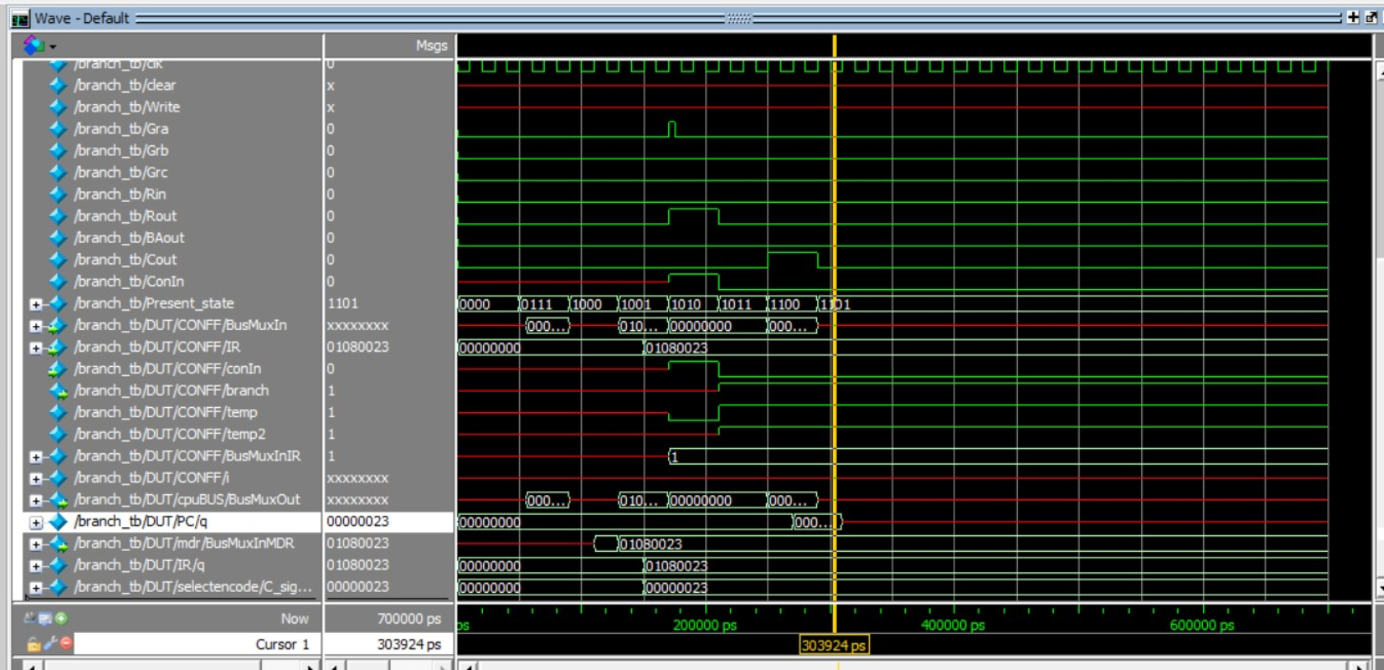

### Brnz instruction – brnz R2, 35

This instruction shows that the design can perform a brnz branch (branch if non-zero) operation on 35 and the value of R2. The steps T0-T2 are executed first, performing the fetch instruction. Then, an operation is performed to determine whether or not to branch. If required, the branch is then performed. Refer to the brzr instruction for the testbench code. The same testbench was used for all branch operations, only the operation code was changed for each.

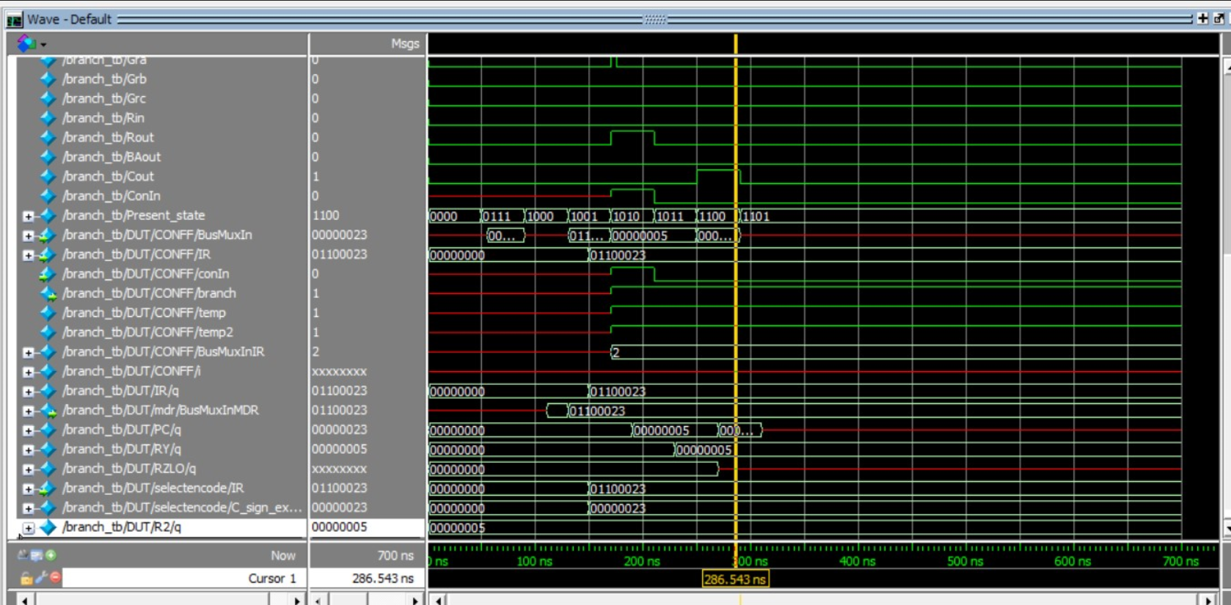

### Brpl instruction – brpl R2, 35

This instruction shows that the design can perform a brpl branch (branch if positive) operation on 35 and the value of R2. The steps T0-T2 are executed first, performing the fetch instruction. Then, an operation is performed to determine whether or not to branch. If required, the branch is then performed. Refer to the brzr instruction for the testbench code. The same testbench was used for all branch operations, only the operation code was changed for each.

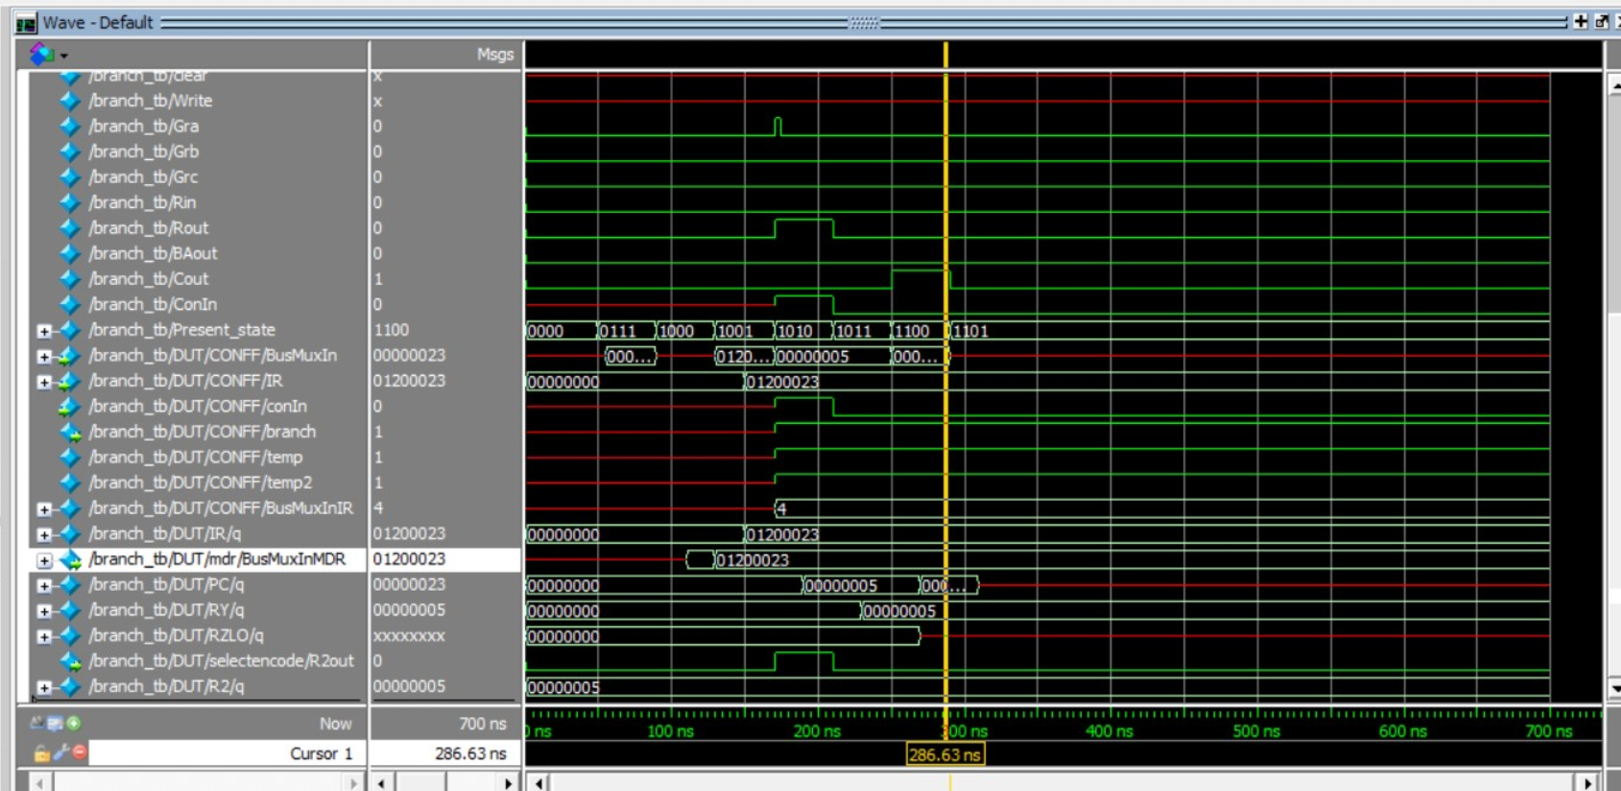

### Brmi instruction – brmi R2, 35

This instruction shows that the design can perform a brmi branch (branch if negative) operation on 35 and the value of R2. The steps T0-T2 are executed first, performing the fetch instruction. Then, an operation is performed to determine whether or not to branch. If required, the branch is then performed. Refer to the brzr instruction for the testbench code. The same testbench was used for all branch operations, only the operation code was changed for each.

